Part A:
Web Distribution
Find the product of the numbers connected by the web.
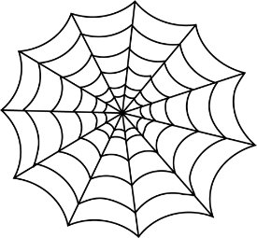
2
5

B
A

2
4
4
C

F
D

3
6
E

A = 20
B = 8
C = 16
D = 12
E = 18
F = 12

Part B:
Decompose the numbers into 2 possible smaller factors.

- 6 = 3 x 2

- 9 = 3 x 3

- 8 = 4 x 2

- 4 = 2 x 2

Part C:
Finish the number bond below.
20
5
5
5
5

