Part A:
Web Distribution
Find the product of the numbers connected by the web.
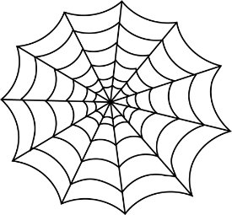
2
5

B
A

2
4
4
C

F
D

3
6
E

A =
B =
C =
D =
E =
F =

Part B:
Decompose the numbers into 2 possible smaller factors.

- 6 = _____ x _____

- 9 = _____ x _____

- 8 = _____ x _____

- 4 = _____ x _____

Part C:
Finish the number bond below.
20

