Name: _____________________________ Period: _______________ Date: ____________

Skip Counting Exit Quiz – Teacher Edition Math 3

Get the product of the following expressions by repeatedly adding 4:

- 4 x 6 = 4 + 4 + 4 + 4 + 4+ 4 = 24
- 4 x 3 = 4 + 4 + 4 = 12

Get the quotient of the following expressions by repeatedly subtracting 4 until it gets to 0:

- 44÷4=44-4-4-4-4-4-4-4-4-4-4-4=0=11
- 32÷4=32-4-4-4-4-4-4-4-4=0=8

Answer the following word problems:

- There are 6 folders on a table. How many folders are on 4 tables? Draw equal groups.
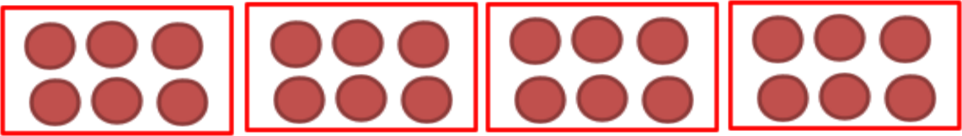

4 x 6 = 24 folders

- There are 48 books on a shelf. How many books are in each row if there are 4 rows? Draw an array model.

48 ÷ 4 = 12 books

Copyright © MathTeacherCoach.com 1

