Part A:
Color the arrays with their corresponding expressions. Overlap the two expressions with 1 row of four.
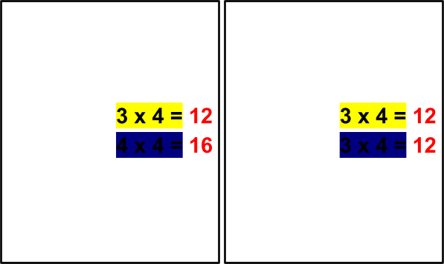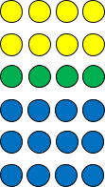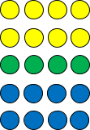

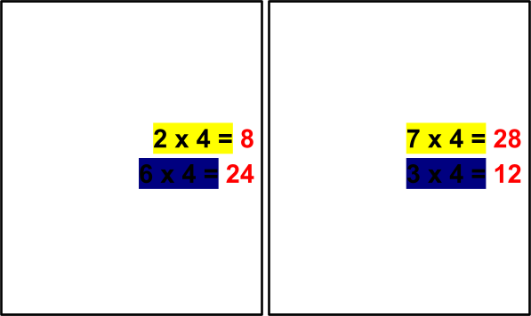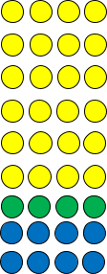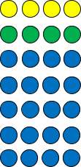

Part B:
Write the multiplication expression for the following arrays. Arrange the letters in order of skip-counting by 4.

A. Expression: 3 x 4 | B. Expression: 4 x 6 | C. Expression: 7 x 4
D. Expression: 4 x 9 | E. Expression: 1 x 4 | F. Expression: 4 x 5
G. Expression: 4 x 8 | H. Expression: 4 x 4 | I. Expression: 4 x 2

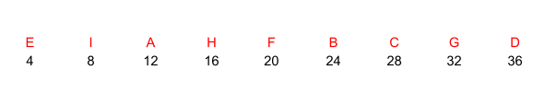

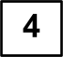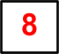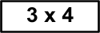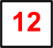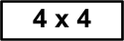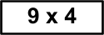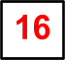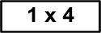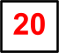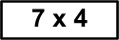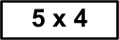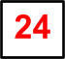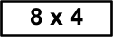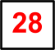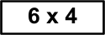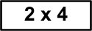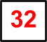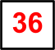Skip count by four going down. Match the answer to its corresponding expression.

Answer the following word problems by skip counting by 4.
- Daniel has 6 boxes of chocolate. Each box contains 4 pieces of chocolates. How many pieces of chocolate does he have altogether?

6 x 4 = 24 pieces of chocolate

- Rectangles have 4 corners. How many corners will be there in 7 rectangles?
7 x 4 = 28 corners

- A group of 4 friends collected 4 unique stones in their backyard. Ho many stones did all of them collect?

4 x 4 = 16 stones

