Part A:
Color the arrays with their corresponding expressions. Overlap the two expressions with 1 row of four.
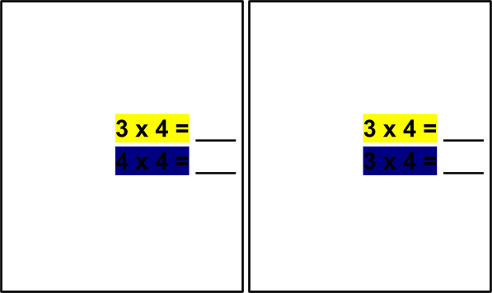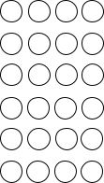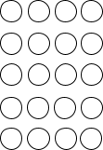

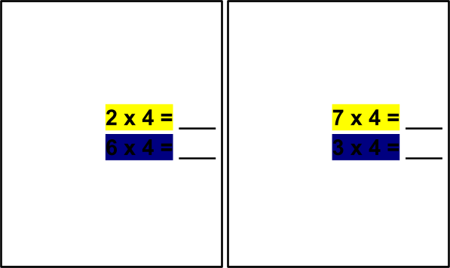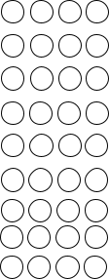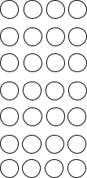

Part B:
Write the multiplication expression for the following arrays. Arrange the letters in order of skip-counting by 4.

A. Expression: | B. Expression: | C. Expression:
D. Expression: | E. Expression: | F. Expression:
G. Expression: | H. Expression: | I. Expression:

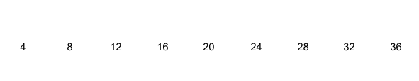

Part C:
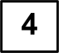Skip count by four going down. Match the answer to its corresponding expression.

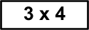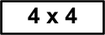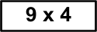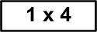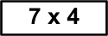

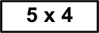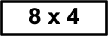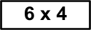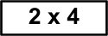

Part D:
Answer the following word problems by skip counting by 4.
- Daniel has 6 boxes of chocolate. Each box contains 4 pieces of chocolates. How many pieces of chocolate does he have altogether?

- Rectangles have 4 corners. How many corners will be there in 7 rectangles?

- A group of 4 friends collected 4 unique stones in their backyard. Ho many stones did all of them collect?

