Part A:
Encircle the following items to the size of each group and identify the number of groups made.

3 groups of 7

2 groups of 4

4 groups of 5

5 groups of 6

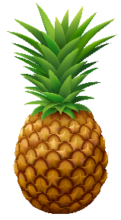

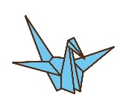
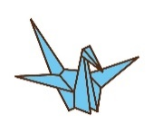
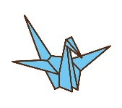

Part B:
Create a number sentence to represent the partitioned objects.
27 ÷ 9 = 3 groups

v

12 ÷ 2 = 6 groups

20 ÷ 4 = 5 groups

14 ÷ 7 = 2 groups

Part C:
Draw the following equations to determine the number of groups.

      - 42 ÷ 6 = 7

      - 32 ÷ 8 = 4

      - 25 ÷ 5 = 5

      - 21 ÷ 3 = 7

Part D:
Answer the following word problems to solve for the number of groups.
            - Mary has 12 oranges. She wants to put them equally in groups with a size of 2. How many plastic bags should she have?

12 ÷ 2 = 6 bags

            - Kyle is drawing a dog with four legs. He drew a total of 20 legs. How many dogs did he draw?

20 ÷ 4 = 5 dogs

            - Ivan has 28 pieces of paper. He gave 4 pieces to each of his friends. How many friends did Ivan give paper to?

28 ÷ 4 = 7 friends

