Part A:
Encircle the following items to the size of each group and identify the number of groups made.

______ groups of 7

______ groups of 4

______ groups of 5

______ groups of 6

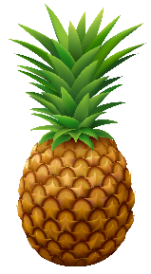

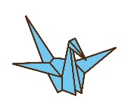
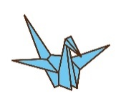
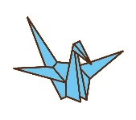

Part B:
Create a number sentence to represent the partitioned objects.
_____ ÷ _____ = _____ groups

v

_____ ÷ _____ = _____ groups

_____ ÷ _____ = _____ groups

_____ ÷ _____ = _____ groups

Part C:
Draw the following equations to determine the number of groups.

      - 42 ÷ 6 =

      - 32 ÷ 8 =

      - 25 ÷ 5 =

      - 21 ÷ 3 =

Part D:
Answer the following word problems to solve for the number of groups.
            - Mary has 12 oranges. She wants to put them equally in groups with a size of 2. How many plastic bags should she have?

            - Kyle is drawing a dog with four legs. He drew a total of 20 legs. How many dogs did he draw?

            - Ivan has 28 pieces of paper. He gave 4 pieces to each of his friends. How many friends did Ivan give paper to?

