Part A:
Counting Sheep
Count the size of the group in terms of the sheep inside the box below.

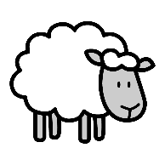
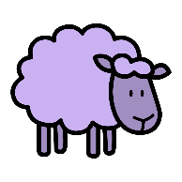
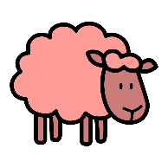

What is the size of the group of white sheep?

What is the size of the group of red sheep?

What is the size of the group of purple sheep?

What is the size of the whole group of sheep?

Part B:
Put the corresponding number of dots in the following containers.

- 8

- 11

- 15

- 10

Part C:
Color the rectangle red if the number of dots is even, and color the rectangle blue if the size is odd.

