Part A:
Connect the dots counting by 2.
24
4
22
6

28
2
20
8

10
18

16
12
14
Part B:
Create your own multiplication sentence and represent it using any object in equal groups. Color your drawings.

5 x 5 = 25
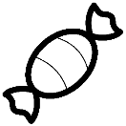

Part C:
Create your own multiplication sentence and represent it using an array of any object. Color your array.

6 x 4 = 24

