Math 4
1-5 Rounding Multi-Digit Whole Numbers
Name: |  | Date:

Common Core Standards | CCSS.MATH.CONTENT.4.NBT.3  Use place value understanding to round multi-digit whole numbers to any place.

1-5 Rounding Multi-Digit Numbers
What does it mean to round?

Rounding is when you find the closest “round” number to any given number.

In this lesson we applied what we learned with “base 10” to round to the nearest 10, 100, and 1,000s.

Benchmark Numbers
We also used benchmark numbers on a number line to help us round our numbers.

We place our benchmark numbers on the number line.
If we’re rounding to the nearest ten our benchmark numbers will be the rounded tens on both sides of our number.

If we’re rounding to the nearest hundred our benchmark numbers will be the rounded hundred on both sides of our number.

If we’re rounding to the nearest thousand our benchmark numbers will be the rounded thousands on both sides of our number.

But what is a “round number”?

Let’s complete this activity to help us understand round numbers, and how to round by using a number line with benchmark numbers.

Activity:
Cut out the pieces to the number line and tape it together from end to end.
- Draw a rectangle around the multiples of ten and fill it in with a different color for each multiple.
- Circle all of the numbers with 5’s in them in-between the multiples of ten (5, 15, 25, 35, etc).
- Mark a colored dot under each number the same color of the rectangle (multiple of 10) that it should round to.

Part A:
What do you notice about the 5’s position in compared to where they are in-between different colored rectangles?

____________________________________________________
What do you notice about the benchmark numbers?
____________________________________________________
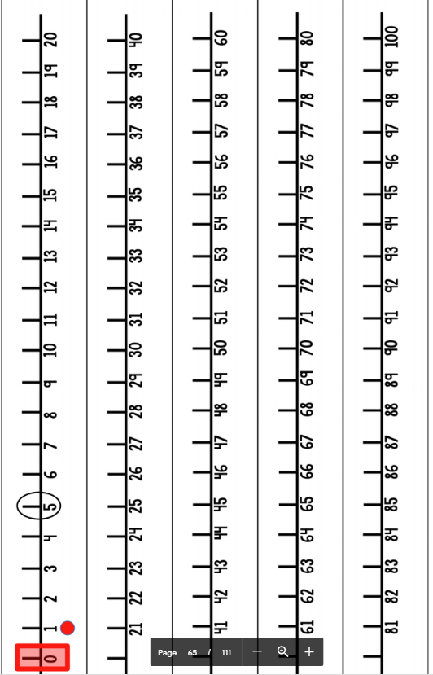

We also learned how to use place value to help us round our numbers!

And we can remember rounding by place value with this simple rhyme:

If it’s four or less give it a rest.
If it's five or more raise the score.

When you want to use our rhyme just remember that you look at the place value below the place value you’re rounding to.

So, you look at the:
- ones place value to round to the nearest ten.
- tens place value to round to the nearest hundred.
- hundreds place value to round to the nearest thousand.

Part B:
Based on the pattern above, if you wanted to round to the nearest thousand what place value would you look at to apply our place value rhyme?

_________________________________________________________

What about if you wanted to round to the nearest million?

_________________________________________________________

Part C:
Let’s identify the place value to use our rounding rhyme!
4,358,761​
Identify:
Place the numbers in their correct period

Fill in the table below for the above numbers:
Millions Period | Thousands Period | Hundreds Period

Hundreds | Tens | Ones | Hundreds | Tens | Ones | Hundreds | Tens | Ones

Question 2:

How do you round 4,358,761 to the nearest hundred thousand using our rhyme? (underline the place value you used)
_________________________________________________

Answer Key

Part A:
What do you notice about the 5’s position in compared to where they are in-between different colored rectangles?

They’re exactly in the middle between the multiples of ten.
What do you notice about the benchmark numbers?
The benchmark numbers all end in zero. They’re round numbers.

Part B:
Based on the pattern above, if you wanted to round to the nearest thousand what place value would you look at to apply our place value rhyme, and why?
We’d look at the hundreds place value, because you look at the place value below the one you’re rounding too.

What about if you wanted to round to the nearest million?
We’d look at the hundred thousands place.

Part C:

Millions Period | Thousands Period | Hundreds Period

Hundreds | Tens | Ones | Hundreds | Tens | Ones | Hundreds | Tens | Ones
 |  | 4 | 3 | 5 | 8 | 7 | 6 | 1

How do you round 4,358,761 to the nearest hundred thousand using our rhyme? (underline the place value you used)
We look at the ten thousands place, because that is the place value below the hundred thousands place. The ten thousands place has a value of 5… So, to apply our rhyme “five or more, give it a score”. Which means we round up to 4,400,000.

