Review
7,482,391​
- Word form: seven million, four hundred eighty-two, three hundred ninety-one​
- Expanded form: 7,000,000 + 400,000 + 80,000 + 2,000 + 300 + 90 + 1​
- Expanded notation: (7x1,000,000)+(4x100,000)+(8x10,000)+(2x1,000)+(3x100)+(9x10)+(1x1)​
How many millions are in the number?
7,482,391 There are 7 millions
How many thousands are in the number?
7,482,391 There are 2 thousands
How many hundred thousands are there?
7,482,391 There are 4 hundred thousands

What does it mean to round a number?

Rounding is when you find the closest “round” number to any given number.

In this lesson we’ll apply what we learned with “base 10” to round to the nearest 10, 100, and 1,000s.

Think about this!

You’re in a car driving along this number line… Your car runs out of gas at the 12 mile marker. There is a gas station both at mile marker 10, and mile marker 20.
Would you go to the gas station at mile marker 10 or mile marker 20?

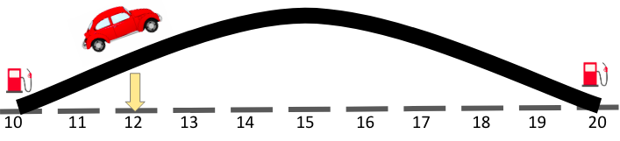
Which gas station is closest?
The gas station at mile marker 10 is closer! We could easily “roll back” to the gas station at mile 10, but it would be much farther to get to the gas station at mile 20.
Time to think!
What if we were at mile 16 past the top of the hill?

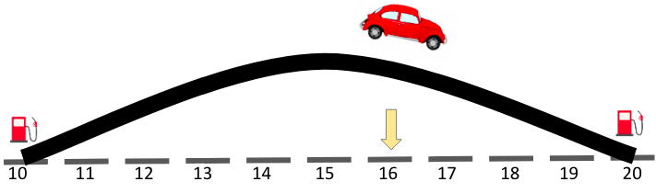
It would be easier to roll forward to the gas station at mile 20 than to go back to the gas station at mile 10.

Time to think!

What if we were at mile 15, right at the top of the hill?

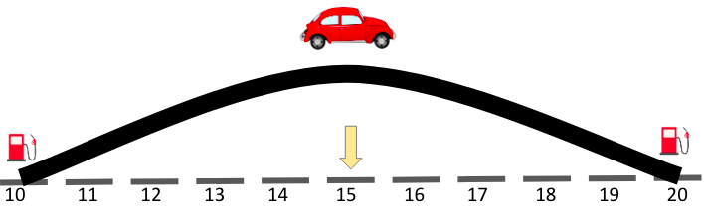

We would round up because it would be easier to roll forward down to the gas station at mile 20 than to go back to the gas station at mile 10.

We can also use place value to help us round our numbers!

Let’s learn how to round to the nearest place value with this simple rhyme:

If it’s four or less give it a rest.
If it's five or more raise the score.

Looking at the ones place value let’s round to the nearest ten.

934
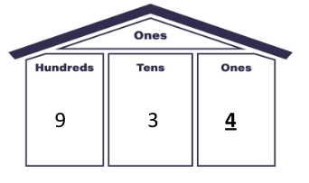
So, should we round up?
Or down?

Down! Because “four or less, give it a rest!”
So, the nearest ten would be 930

Benchmark Numbers
We can also use benchmark numbers on a number line to help us round our numbers.

We place our benchmark numbers on the number line.
If we’re rounding to the nearest ten our benchmark numbers will be the rounded tens on both sides of our number.

Let’s round 76 to the nearest ten...

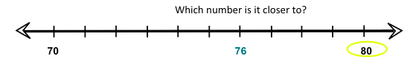

80!
And we can also apply our rhyme “Five or more, raise the score!”

We can use benchmark numbers to help us round to the nearest hundred too!

We place our benchmark numbers on the number line.
If we’re rounding to the nearest hundred our benchmark numbers will be the round hundreds on both sides of our number.

Let’s round 942 to the nearest hundred...

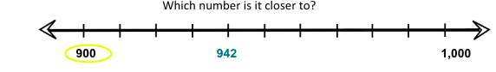
900!

And we can also apply our rhyme “Four or less, give it a rest!” because when rounding to the nearest hundred we use the tens place to tell us whether to go up or down.

Let’s do some thinking!

Round 2,589 to the nearest thousand…

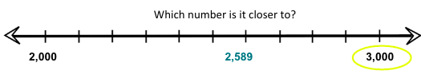

3,000!

If we wanted to apply our rhyme what place value would we look at in order to round to the nearest thousand?

The hundreds place! Because you always look at one place below the place value you’re rounding to.

2,589
Five or more, give it a score!
Round up to 3,000!

Sample Problem 1
Round 458 to the nearest ten…

Place your benchmark numbers on the number line.
If we’re rounding to the nearest ten our benchmark numbers will be the round tens on both sides of our number.

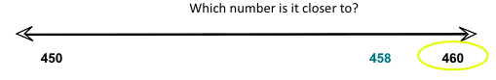

460!

If we wanted to apply our rhyme what place value would we look at in order to round to the nearest ten?

The ones place! Because you always look at one place below the place value you’re rounding to.

458
Five or more, give it a score!
Round up to 460!

Sample Problem 2
Round 7,719 to the nearest hundred…

Place your benchmark numbers on the number line.
If we’re rounding to the nearest hundred our benchmark numbers will be the round hundreds on both sides of our number.

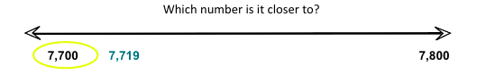

7,700!

If we wanted to apply our rhyme what place value would we look at in order to round to the nearest hundred?

The tens place! Because you always look at one place below the place value you’re rounding to.

7,719
Four or less, give it a rest!
Round down to 7,700!

Sample Problem 3
Round 23,607 to the nearest thousand…

Place your benchmark numbers on the number line.
If we’re rounding to the nearest thousand our benchmark numbers will be the round thousands on both sides of our number.

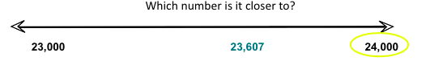

24,000!

If we wanted to apply our rhyme what place value would we look at in order to round to the nearest thousand?

The hundreds place! Because you always look at one place below the place value you’re rounding to.

23,607
Five or more, give it a score!
Round up to 24,000!

Sample Problem 4
There were 8,563 people traveling to Disney World this summer. About how many people, rounded to the nearest hundred were traveling to Disney World?

We used our benchmark numbers on the number line to help us figure it out! When we’re rounding to the nearest hundred our benchmark numbers are the round hundreds on both sides of our number.

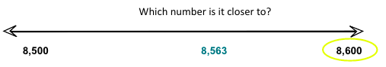

8,600!

If we wanted to apply our rhyme what place value would we look at in order to round to the nearest hundred?

The tens place! Because you always look at one place below the place value you’re rounding to.

8,563
Five or more, give it a score!
Round up to 8,600!

