Review
7,482,391​
- Word form: _____________________________________________________________
- Expanded form: _____________________________________________________________
- Expanded notation: _____________________________________________________________
How many millions are in the number?
_____________________________________________________________
How many thousands are in the number?
_____________________________________________________________
How many hundred thousands are there?
_____________________________________________________________

What does it mean to round a number?

Rounding is when you find the ________________________________ to any given number.

In this lesson we’ll apply what we learned with “base 10” to round to the nearest 10, 100, and 1,000s.

Think about this!

You’re in a car driving along this number line… Your car runs out of gas at the 12 mile marker. There is a gas station both at mile marker 10, and mile marker 20.
Would you go to the gas station at mile marker 10 or mile marker 20?

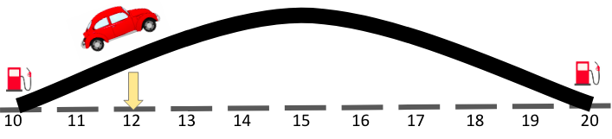
Which gas station is closest?
____________________________________________________________________________________________________________________
Time to think!
What if we were at mile 16 past the top of the hill?

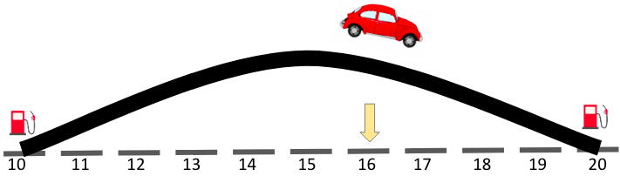
It would be easier to roll _________________________________ to the gas station at mile ______________________ than to __________________ to the gas station at mile ___________________.

Time to think!

What if we were at mile 15, right at the top of the hill?

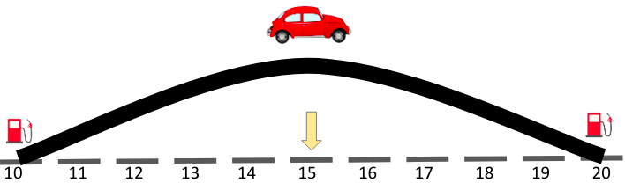

We would round ______________ because it would be easier to roll ___________________ down to the gas station at mile ________________ than to go back to the gas station at mile _____________________.

We can also use place value to help us round our numbers!

Let’s learn how to round to the nearest place value with this simple rhyme:

If it’s _______ or less give it a rest.
If it's _________ or more raise the score.

Looking at the ones place value let’s round to the nearest ten.

934
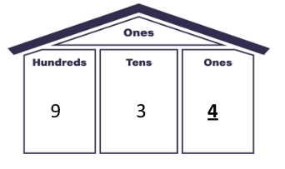

So, should we round up?
Or down?

______________! Because “four or less, give it a rest!”
So, the nearest ten would be _______________.

Benchmark Numbers
We can also use ______________ numbers on a number line to help us round our numbers.

We place our benchmark numbers on the number line.
If we’re rounding to the nearest ten our benchmark numbers will be the rounded tens on both sides of our number.

Let’s round 76 to the nearest ten...
80
70
76

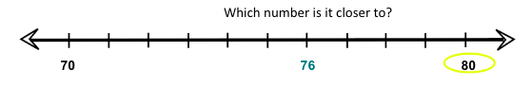
Which number is it closer to?

___0!

And we can also apply our rhyme “Five or more, raise the score!”

We can use benchmark numbers to help us round to the nearest hundred too!

We place our benchmark numbers on the number line.
If we’re rounding to the nearest hundred our benchmark numbers will be the round ___________on both sides of our number.

Let’s round 942 to the nearest hundred...
1,000
900
942
Which number is it closer to?

______!

And we can also apply our rhyme “____________ or less, give it a rest!” because when rounding to the nearest hundred we use the ___________ place to tell us whether to go up or down.

Let’s do some thinking!

Round 2,589 to the nearest thousand…
3,000
2,000
2,589
Which number is it closer to?

__,000!

If we wanted to apply our rhyme what place value would we look at in order to round to the nearest thousand?

The ______________ place! Because you always look at one place ___________ the place value you’re rounding to.

2,589
Five or more, give it a score!
Round up to 3,000!

Sample Problem 1
Round 458 to the nearest ten…

Place your benchmark numbers on the number line.
If we’re rounding to the nearest ten our benchmark numbers will be the round __________ on both sides of our number.

460
450
458
Which number is it closer to?

4__0!

If we wanted to apply our rhyme what place value would we look at in order to round to the nearest ten?

The ________________ place! Because you always look at one place ________________ the place value you’re rounding to.

458
Five or more, give it a score!
Round _____ to 4__0!

Sample Problem 2
Round 7,719 to the nearest hundred…

Place your benchmark numbers on the number line.
If we’re rounding to the nearest hundred our benchmark numbers will be the round ______________ on both sides of our number.

7,800
7,700
7,719
Which number is it closer to?

7,__00!

If we wanted to apply our rhyme what place value would we look at in order to round to the nearest hundred?

The ____________ place! Because you always look at one place below the place value you’re rounding to.

7,719
Four or less, give it a rest!
Round _________ to 7,_______!

Sample Problem 3
Round 23,607 to the nearest thousand…

Place your benchmark numbers on the number line.
If we’re rounding to the nearest thousand our benchmark numbers will be the round _______________ on both sides of our number.

24,000
23,000
23,607
Which number is it closer to?

2__,000!

If we wanted to apply our rhyme what place value would we look at in order to round to the nearest thousand?

The _______________ place! Because you always look at one place below the place value you’re rounding to.

23,607
Five or more, give it a score!
Round _________ to 2__,000!

Sample Problem 4
There were 8,563 people traveling to Disney World this summer. About how many people, rounded to the nearest hundred were traveling to Disney World?

We used our benchmark numbers on the number line to help us figure it out! When we’re rounding to the nearest hundred our benchmark numbers are the round ___________ on both sides of our number.

8,600
8,500
8,563
Which number is it closer to?

8,__00!

If we wanted to apply our rhyme what place value would we look at in order to round to the nearest hundred?

The _______ place! Because you always look at one place below the place value you’re rounding to.

8,563
Five or more, give it a score!
Round ____ to 8,__00!

