**Part A:**

1. Use the number line to round 32,654 to the nearest ten 32,650

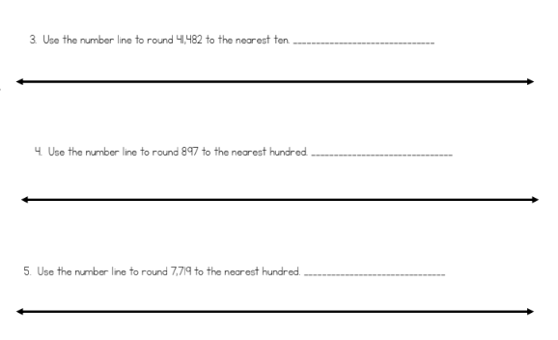

32,654

32,6600

32,650

1. Use the number line to round 62,467 to the nearest hundred 62,500



62,467

62,500

62,400

1. Use the number line to round 12,678 to the nearest thousand 13,000



12,678

13,000

12,000

1. Use the number line to round 312,678 to the nearest ten thousand 310,000



320,000

312,678

310,000

1. Use the number line to round 637,891 to the nearest hundred thousand 600,000



637,891

700,000

600,000

**Part B:**

1. **Round to the nearest ten above and below and circle the rounded number that is closest to the given number.**
2. 52,360 52,364 52,370 C) 134,680 134,682 134,690
3. 21,640 21,645 21,650 D) 46,230 46,238 46,240

**Part C:**

**Round the following numbers to the nearest ten.**

1. 12,678 12,680 2. 423,124 423,120 3. 62,834 62,830

**Round the following numbers to the nearest hundred.**

4. 264,812 264,800 5. 352,731 352,700 6. 23,642 23,600

**Round the following numbers to the nearest thousand.**

7. 51,723 52,000 8. 573,642 574,000 9. 186,493 186,000

**Round the following numbers to the nearest ten thousand.**

10. 135,843 140,000 11. 935,864 940,000 12. 32,843 30,000

**Round the following numbers to the nearest hundred thousand.**

13. 873,642 900,000 14. 365,882 400,000 15. 681,948 700,000