Review
7,482,391​
- Word form: seven million, four hundred eighty-two, three hundred ninety-one​
- Expanded form: 7,000,000 + 400,000 + 80,000 + 2,000 + 300 + 90 + 1​
- Expanded notation: (7x1,000,000)+(4x100,000)+(8x10,000)+(2x1,000)+(3x100)+(9x10)+(1x1)​
Let's look at the symbols that help us compare numbers!​
- < less than​
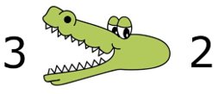
- > greater than​
- = equal to
Remember how to compare!​
Gary Gator always wants to
"eat" the bigger number! Three is greater than Two

How to Compare Numbers using Place Value​
We can use place value to visualize how to compare large numbers​

1. Compare the numbers in their designated period

2. Look at the highest place value and compare those numbers​

3,461,582 < 4,358,761
Hundreds​ | Tens​ | Ones​ | Hundreds​ | Tens​ | Ones​ | Hundreds​ | Tens​ | Ones​
​ | ​ | 3​ | 4​ | 6​ | 1​ | 5​ | 8​ | 2​
​ | ​ | 4​ | 3​ | 5​ | 8​ | 7​ | 6​ | 1​

Time to Think
Problem 1:
Fill in the place value houses to help compare your numbers:
583,201 > 294,413​
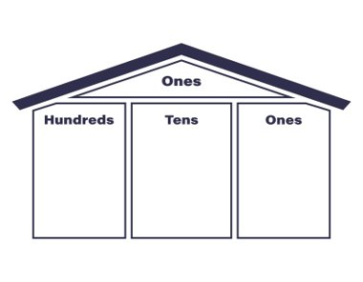
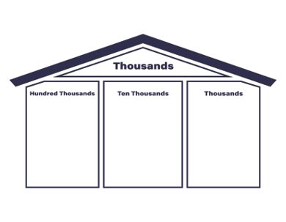

What did we notice about the number on the right?
We noticed that the number on the right had numbers larger in each place value leading up into the highest place value​.
Time to Think
Problem 2:
946,109 < 947,604​

What was the highest place value that was different between our two numbers?

The thousands place
Time to Think
Problem 3:
Look at the highest place value where there's a difference to compare the large numbers​

5,358,543 < 5,358,790

What's the highest place value with a difference?

The hundreds place

Vocabulary Cards:
Label and draw the appropriate symbol for each vocab card!
Compare  To compare means to look for similarities or differences between two different things (or numbers). | Equal  =  When two numbers have the exact same value
Greater Than  >  The number on the left has a value greater than the number on the right | Less Than  <  The number on the left has a value less than the number on the right

