Review
7,482,391​
- Word form: _____________________________________________________________
- Expanded form: _____________________________________________________________
- Expanded notation: _____________________________________________________________

Let's look at the symbols that help us compare numbers!​
- < less than​
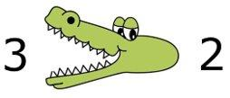
- > greater than​
- = equal to
Remember how to compare!​
Gary Gator always wants to
"eat" the bigger number! Three is _________ Two
How to Compare Numbers using Place Value​
We can use place value to visualize how to compare large numbers​

1. Compare the numbers in their designated ______________.

2. Look at the ____________ place value and compare those numbers​

3,461,582 4,358,761
Hundreds​ | Tens​ | Ones​ | Hundreds​ | Tens​ | Ones​ | Hundreds​ | Tens​ | Ones​
​ | ​ | 3​ | 4​ | 6​ | 1​ | 5​ | 8​ | 2​
​ | ​ | 4​ | 3​ | 5​ | 8​ | 7​ | 6​ | 1​

Time to Think
Problem 1:
Fill in the place value houses to help compare your numbers:
583,201 294,413​
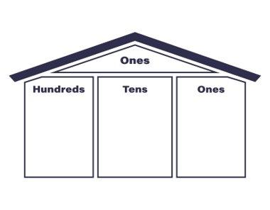
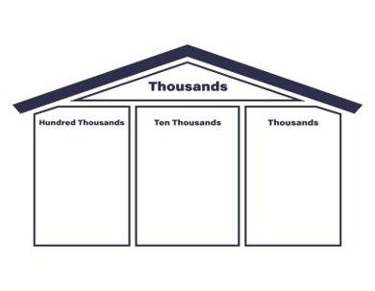

What did we notice about the number on the right?
____________________________________________________
Time to Think
Problem 2:
946,109 947,604​

What was the highest place value that was different between our two numbers?

___________________________________________________________________
Time to Think
Problem 3:
Look at the highest place value where there's a difference to compare the large numbers​

5,358,543 5,358,790

What's the highest place value with a difference?

____________________________________________________

Vocabulary Cards:
Label and draw the appropriate symbol for each vocab card!
Compare | Equal
Greater Than | Less Than

