Math 4

1-3 Forms of Multi-digit Numbers
Name: |  | Date:

Common Core Standards | CCSS.MATH.CONTENT.4.NBT.2  Read and write multi-digit whole numbers using base-ten numerals, number names, and expanded form. Compare two multi-digit numbers based on meanings of the digits in each place, using >, =, and < symbols to record the results of comparisons.

1-3 Forms of Multi-digit Numbers
Numeral Periods & Expanded Notation

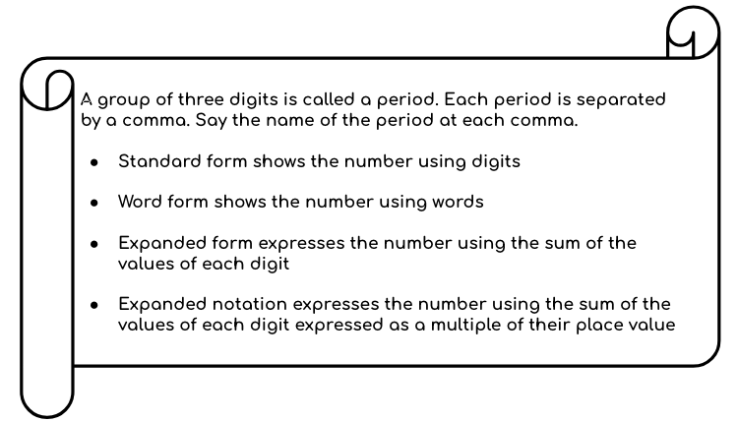

7,463,152
Millions Period | Thousands Period | Hundreds Period

Hundreds | Tens | Ones | Hundreds | Tens | Ones | Hundreds | Tens | Ones
 |  | 7 | 4 | 6 | 3 | 1 | 5 | 2

Identify:
Place the numbers in their correct period

Fill in the table below for the following numbers:
375,284
6,843,209
4,352,176
Millions Period | Thousands Period | Hundreds Period

Hundreds | Tens | Ones | Hundreds | Tens | Ones | Hundreds | Tens | Ones

Write out their full expanded notation below:
375,284 ___________________________________________
6,843,209 ___________________________________________
4,352,176 ___________________________________________

Forms of Multi-digit Numbers

Situation:
- Kevin wrote the expanded notation for: 417,352. Find and correct his mistakes.

(4x100,000) + (4x10,000) + (7x1,000) + (3x100) + (5x100) +(2x1)

__________________________________________
__________________________________________
__________________________________________
__________________________________________

Part A: Write out the number its different forms.
731,290

Expanded Form = _________________________________
Expanded Notation = _________________________________

Part B: Identify the number by its expanded form:
- (3x1,000,000)+(6x100,000)+(4x10,000)+(7x100)+(8x1)
__________________________

- (5 x100,000)+(8x10,000)+(3x1,000)+(9x100)+(2x10)+(8x1)
__________________________

Part C: Task Cards
Match the pink card to the blue card with the correct matching phrase of the given numerical expressions.

1.  $$3,058,921$$ |  | a.  (8x100,000)+(2x10,000)+(7x1,000)+(2x100)+(5x10)+(3x1)
2.  $$1,738,952$$ |  | b.  (3x100,000)+(8x10,000)+(5x1,000)+(4x100)+(1x10)+(8x1)

3.
$$827,253$$
c.
(3x1,000,000) + (5x10,000)+(8x1,000)+(9x100)+(2x10)+(1x1)

4.  $$385,418$$ |  | d.  (1x1,000,000)+(5x100,000)+(9x10,000)+(6x1,000)+(7x100)+(2x10)
5.  $$1,596,720$$ |  | e.  (1x1,000,000)+(7x100,000)+(5x10,000)+(8x1,000)+(9x100)+(2x10)+(1x1)

Millions Period | Thousands Period | Hundreds Period
Answer Key
Hundreds | Tens | Ones | Hundreds | Tens | Ones | Hundreds | Tens | Ones
 |  |  | 3 | 7 | 5 | 2 | 8 | 4
 |  | 6 | 8 | 4 | 3 | 2 | 0 | 9
 |  | 4 | 3 | 5 | 2 | 1 | 7 | 6
375,284
(3x100,000)+(7x10,000)+(5x1,000)+(2x100)+(8x10)+(4x1)
6,843,209
(6x1,000,000)+(8x100,000)+(4x10,000)+(3x1,000)+(2x100)+(9x1)
4,352,176
(4x1,000,000)+(3x100,000)+(5x10,000)+(2x1,000)+(1x100)+(7x10)+(6x1)

 | Situation 1 | It should be written: (4x100,000) + (1x10,000) + (7x1,000) + (3x100) + (5x10) +(2x1)  Kevin wrote (5x100) instead of (5x10) and (4x10,000) instead of (1x10,000)
 | Part A: | 700,000 + 30,000 + 1,000 + 200 + 90
 |  | (7x100,000) + (3x10,000) + (1x1,000) + (2x100) + (9x10)
 | Part B:
 | 1. | 3,640,701
 | 2. | 583,928
Part C:
Task Cards
 | 1. | c.
 | 2. | e.
 | 3. | a.
 | 4. | b.
 | 5. | d.

