Review
6,125,426
- Number form: 6,125,426
- Word form: six million, one hundred twenty-five thousand, four hundred twenty-six
- Expanded form: 6,000,000 + 100,000 + 20,000 + 5,000 + 400 + 20 + 6
- How many thousands are in the number?
  - There are five thousands
- How many hundreds are in the number?
  - There are four hundreds
- How many hundred thousands are there?
  - There is one hundred thousand
- How many millions are there?
  - There are six millions

Understanding numeral periods and the commas that separate them will help us with learning Expanded Number Notation!

8,347,592

Millions Period | Thousands Period | Hundreds Period

Hundreds | Tens | Ones | Hundreds | Tens | Ones | Hundreds | Tens | Ones
 |  | 8 | 3 | 4 | 7 | 5 | 9 | 2

In our last lesson we learned about expanded form that looked like this:
8,000,000 + 300,000 + 40,000 + 7,000 + 500 + 90 + 2

In this lesson we’ll break it down even further into expanded notation which looks like this:

(8x1,000,000) + (3x100,000) + (4x10,000) + (7x1,000) + (5x100) + (9x10) + (2x1)

Time to Think
Problem 1:
426,512
Hundred thousands: 4 x 100,000
Ten thousands: 2 x 20,000
Thousands: 6 x 1,000
Hundreds: 5 x 100
Tens: 1 x 10
Ones: 2 x 1
Expanded Form:
400,000 + 20,000 + 6,000 + 500 + 10 + 2
Expanded Notation:
(4 x 100,00) + (1 x 20,000) + (6 x 1,000) + (5 x 100) + (1 x 10) + (2 x 1)
Time to Think
Problem 2:
2,375,014
Millions: 2 x 1,000,000
Hundred thousands: 3 x 100,000
Ten thousands: 7 x 10,000
Thousands: 5 x 1,000
Hundreds: 0 x 100
Tens: 1 x 10
Ones: 4 x 1
Expanded Form:
2,000,000 + 300,000 + 70,000 + 5,000 + 10 + 4
Expanded Notation:
(2x1,000,000) + (3x100,000) + (7x10,000) + (5x1,000) + (0x100) + (1x10) + (4x1)

Time to Think
Problem 3:
934,251
Fill out the place value tentacles with their expanded notation:
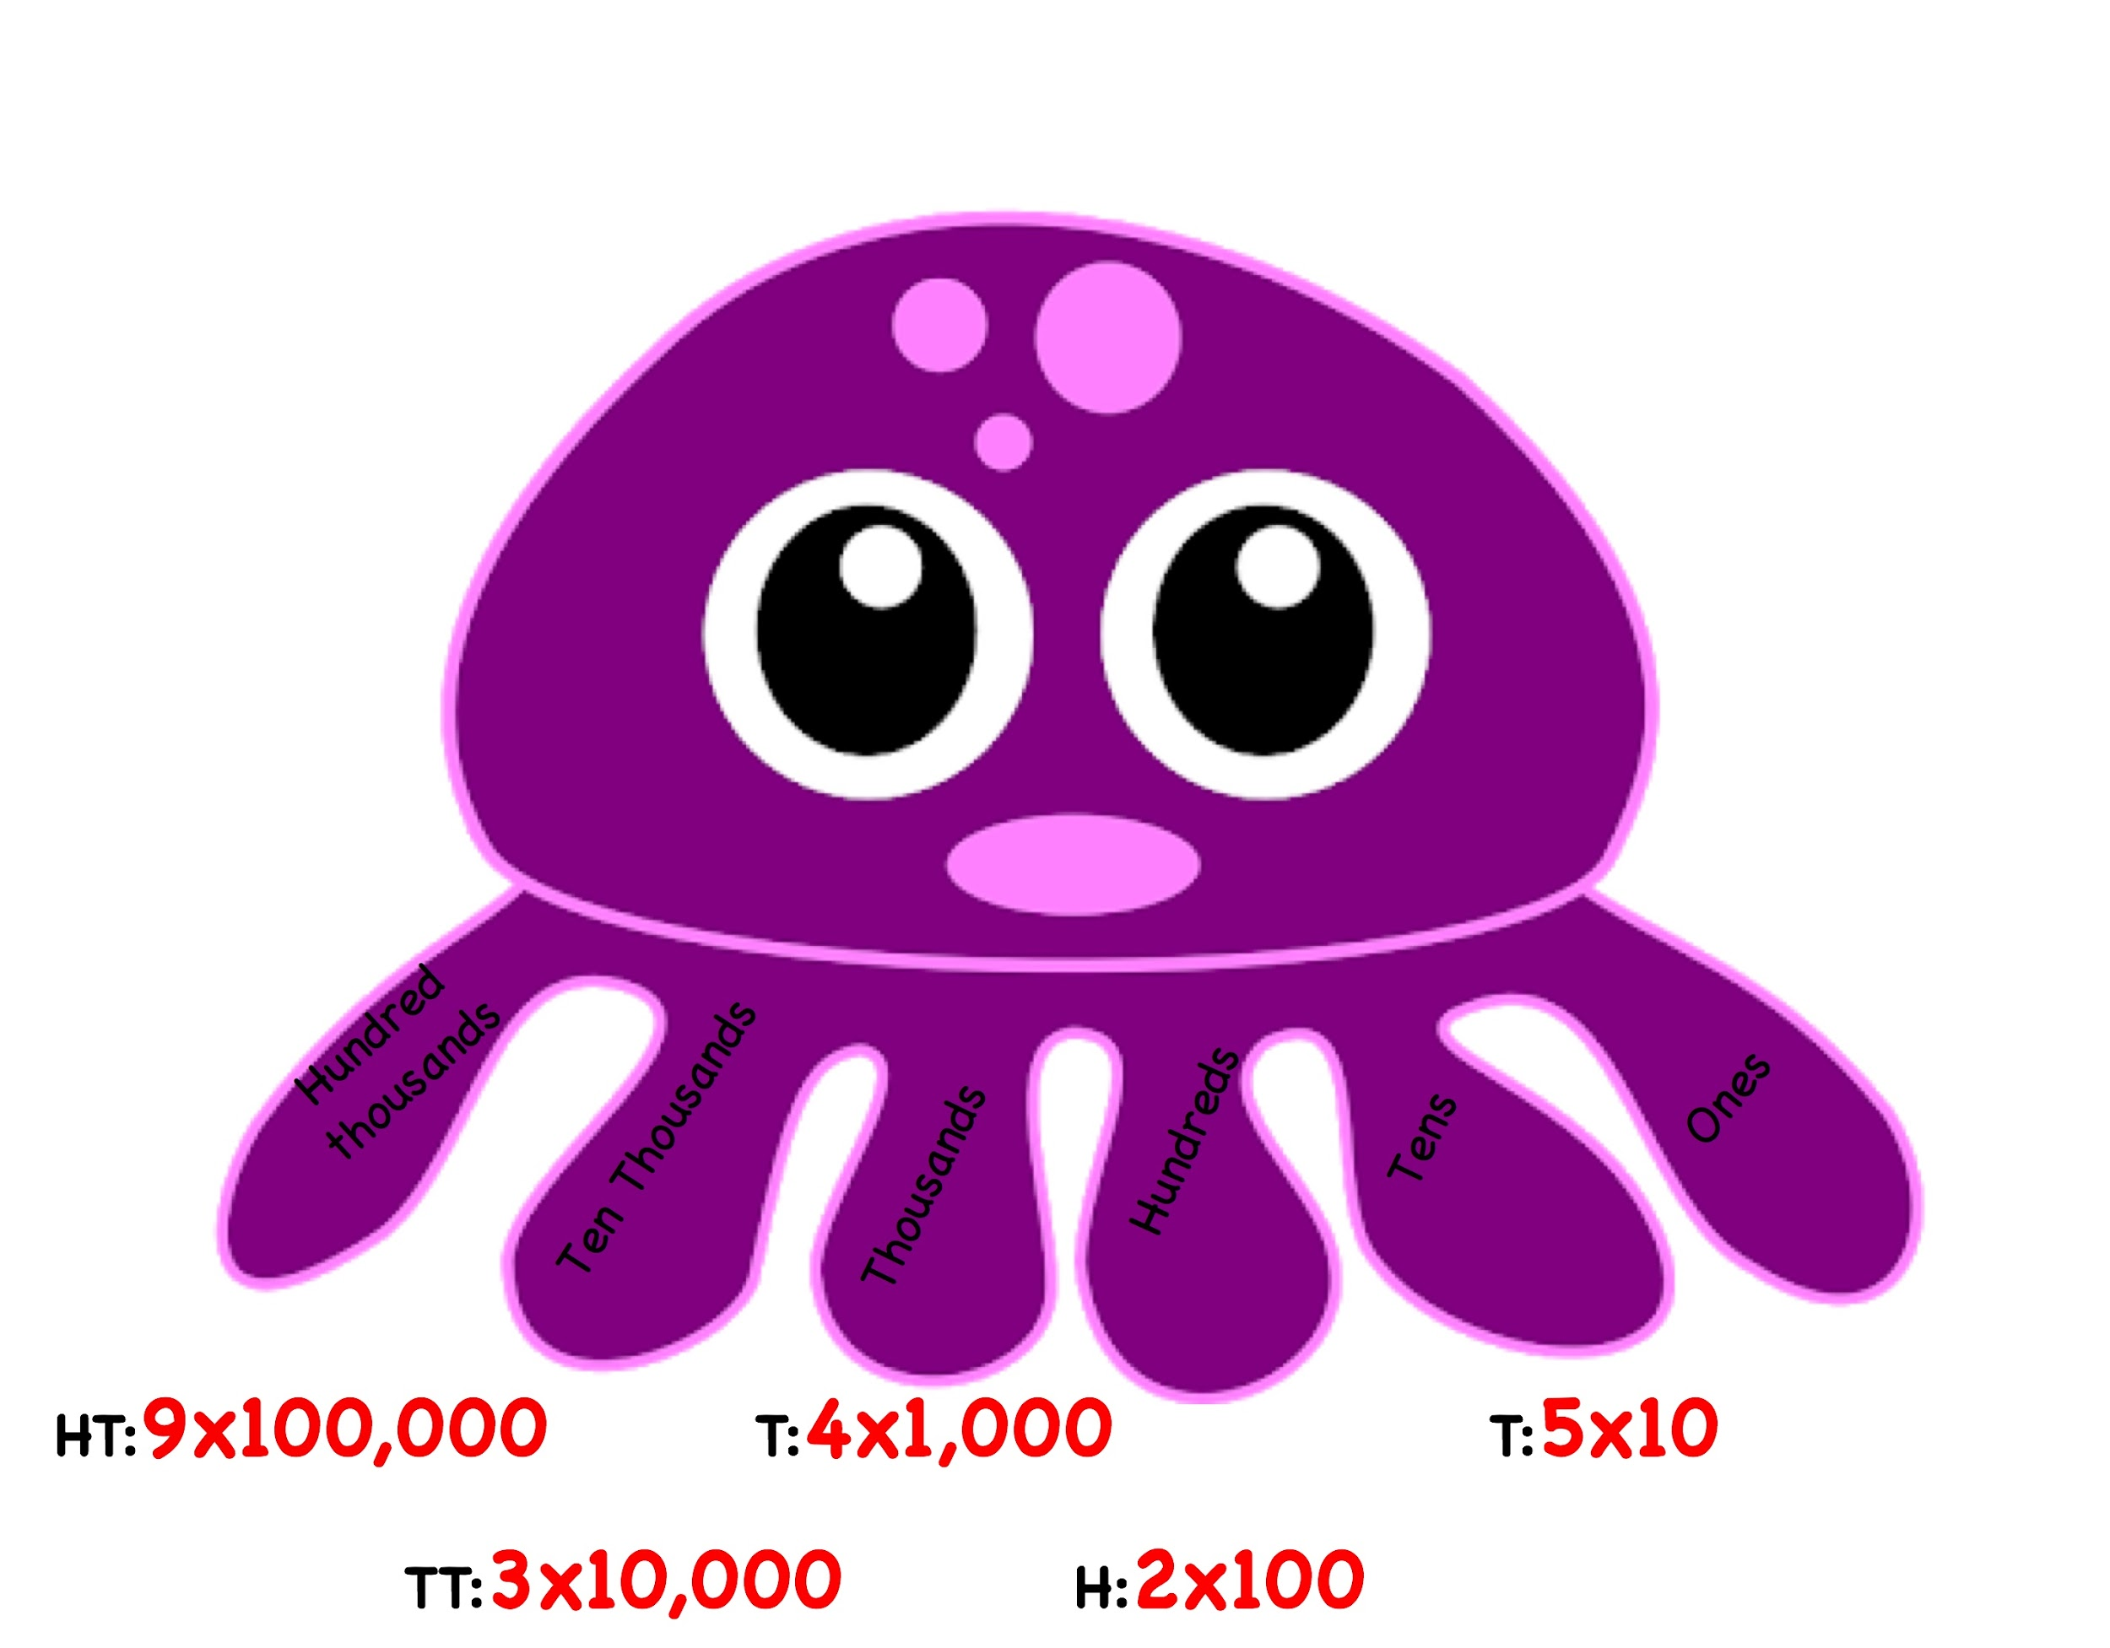
Write out the full expanded notation below:
(9x100,000) + (3x10,000) + (4x1,000) + (2x100) + (5x10) + (1x1)
Time to Think
Problem 4:
8,437,265
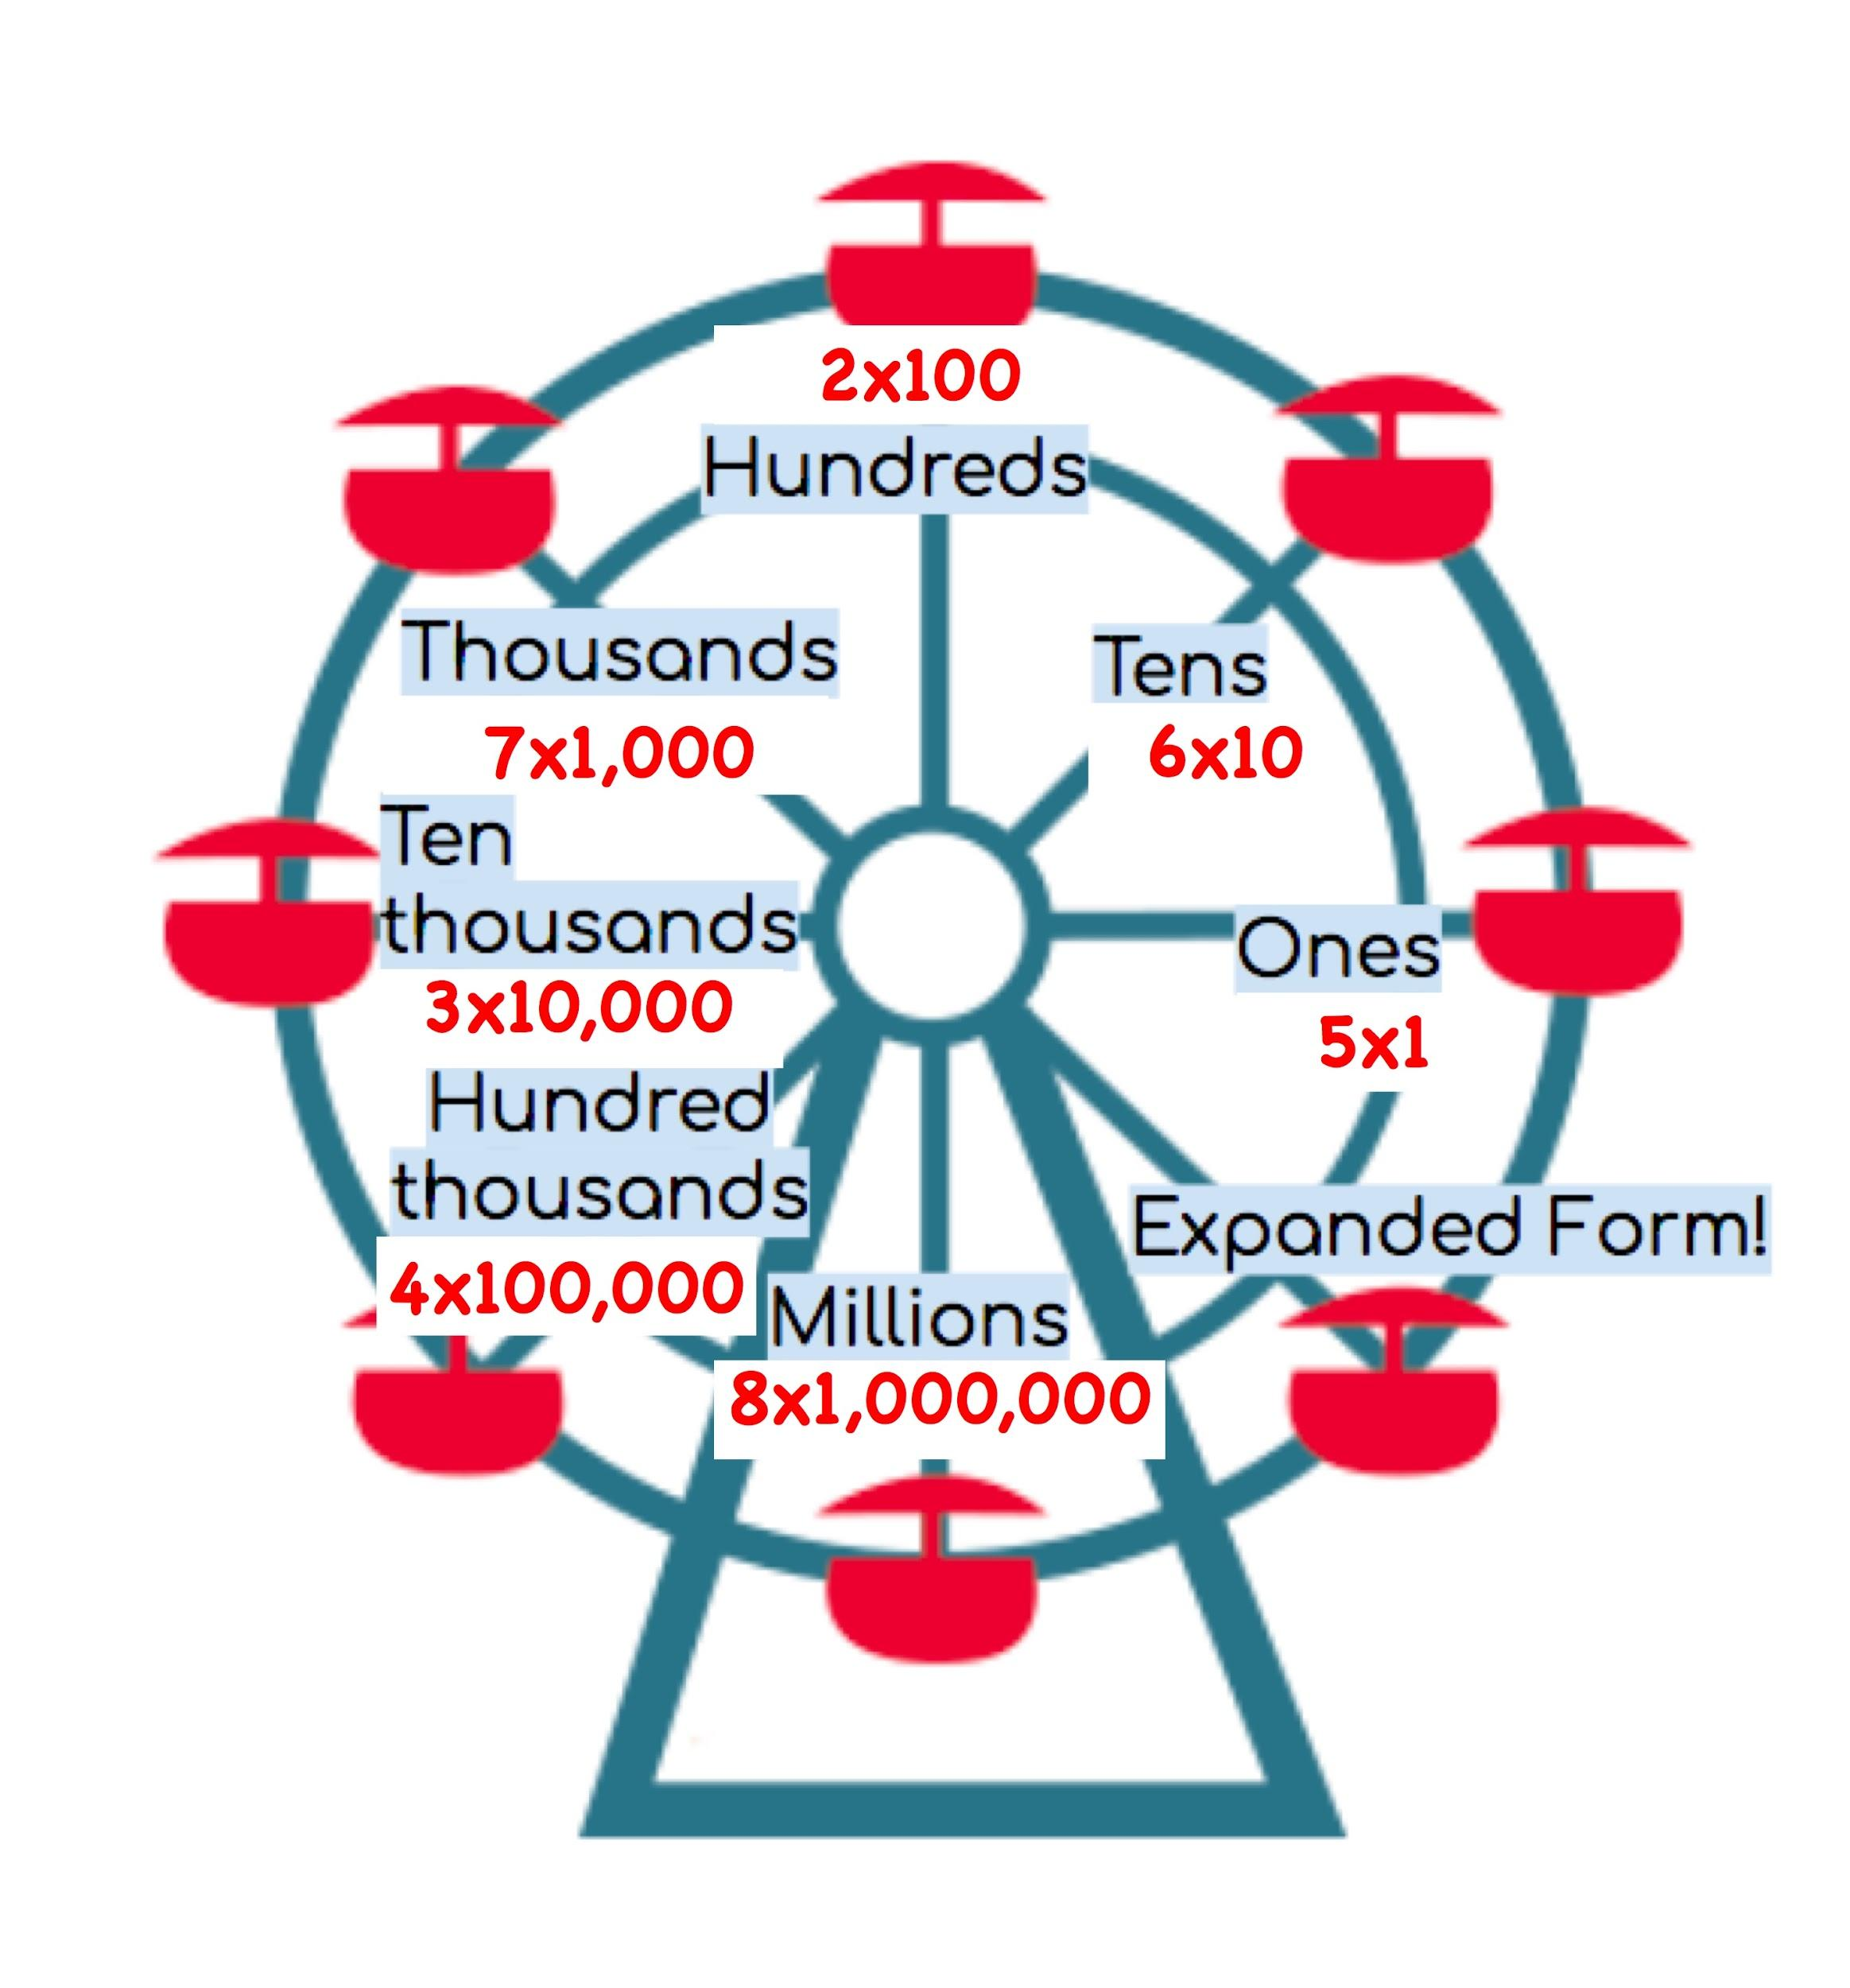
Fill out the place value baskets with their expanded notation:

Write out the expanded form below:
8,000,000 + 400,000 + 30,000 + 7,000 + 200 + 60 + 5

Write out the full expanded notation below:
(8x1,000,000) + (4x100,000) + (3x10,000) + (7x1,000) + (2x100) + (6x10) + (5x1)

Activity: You can either allow the students to cut out and prepare this flip book themselves, or pre-cut and prepare them to save time during class.

- Cut out the different sections and glue them into your flip book.
- After gluing on your labels fill out your flip book with all of the different ways to write your number.
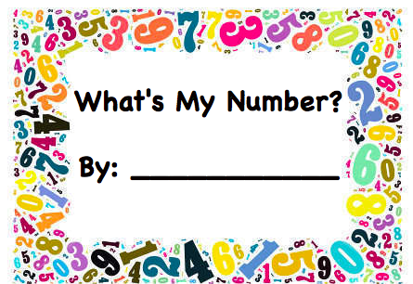

Number Word
Standard Form
Expanded Form
Expanded Notation

