Review
6,125,426
- Number form: ________________________________
- Word form: __________________________________
- Expanded form: ______________________________
- How many thousands are in the number?
  - ______________________________
- How many hundreds are in the number?
  - ______________________________
- How many hundred thousands are there?
  - ______________________________
- How many millions are there?
  - ______________________________

Numeral Periods & Expanded Number Notation
Understanding numeral periods and the commas that separate them will help us with learning Expanded Number Notation!

8,347,592

Millions Period | Thousands Period | Hundreds Period

Hundreds | Tens | Ones | Hundreds | Tens | Ones | Hundreds | Tens | Ones
 |  | 8 | 3 | 4 | 7 | 5 | 9 | 2

In our last lesson we learned about expanded form that looked like this:
8,000,000 + 300,000 + 40,000 + 7,000 + 500 + 90 + 2

In this lesson we’ll break it down even further into expanded notation which looks like this:

(8x1,000,000) + (3x100,000) + (4x10,000) + (7x1,000) + (5x100) + (9x10) + (2x1)

Time to Think
Problem 1:
426,512
Hundred thousands: ___________________________
Ten thousands: _______________________________
Thousands: __________________________________
Hundreds: ___________________________________
Tens: _______________________________________
Ones: ______________________________________
Expanded Form:
____________________________________________________
Expanded Notation:
____________________________________________________
Time to Think
Problem 2:
2,375,014
Millions: _____________________________________
Hundred thousands: ___________________________
Ten thousands: _______________________________
Thousands: __________________________________
Hundreds: ___________________________________
Tens: _______________________________________
Ones: ______________________________________
Expanded Form:
____________________________________________________
Expanded Notation:
____________________________________________________

Time to Think
Problem 3:
934,251
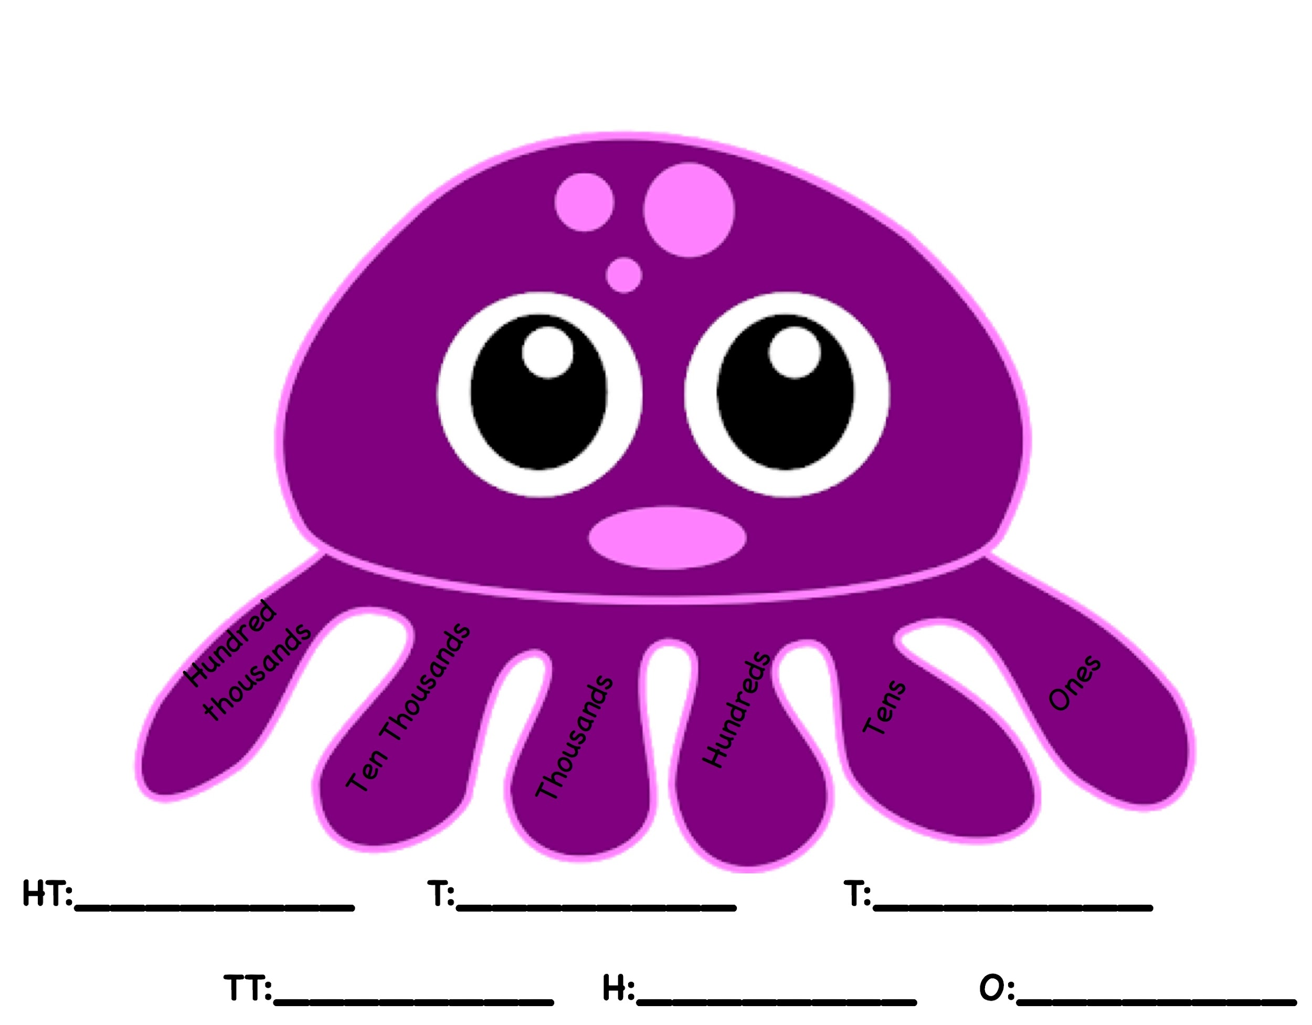
Fill out the place value tentacles with their expanded notation:

Write out the full expanded notation below:
____________________________________________________
Time to Think
Problem 4:
8,437,265
Fill out the place value baskets with their expanded notation:
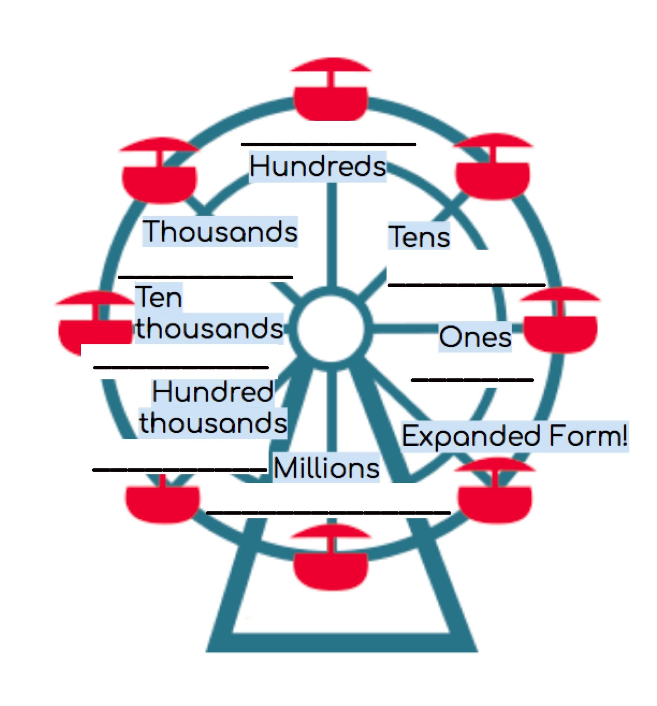

Write out the expanded form below:
____________________________________________________

Write out the full expanded notation below:

- Cut out the different sections and glue them into your flip book.
- After gluing on your labels fill out your flip book with all of the different ways to write your number!
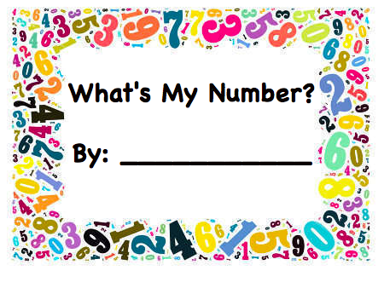

Number Word
Standard Form
Expanded Form
Expanded Notation

