Place Value Puzzle
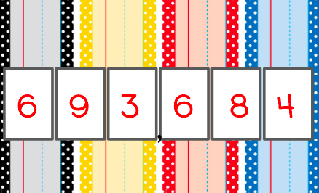

- Multiply the sum of 3 and 1 by 2 and write your answer in the tens place
8

- Divide the number of days (normally) in February by how many days there are in a week and write your answer in the ones place.
4

- Subtract half a dozen from a dozen and write that in the hundreds place.
6

- Add those first three answers together and subtract 9 and write your answer in the ten thousands place.
9

- Divide the number of minutes in an hour by ten and put your answer in the hundred thousands place.
6

- Multiply that number by five, and then divide it by ten. Put your answer in the thousands place.
3

