Review
- Start naming new place value units by how many one thousands, ten thousands, and hundred thousands there are.
- Commas are used to show the grouping of units.
Problem 1:
350,654
How many thousands are in the number?
There are zero thousands.
How many hundreds are in the number?
There are six hundreds.
How many hundred thousands are there?
There are three hundred thousands.
Where should the comma be placed?
Problem 2:
7,235,642
How many thousands are in the number?
There are five thousands.
How many hundreds are in the number?
There are six hundreds.
How many hundred thousands are there?
There are two hundred thousands.
Where should the comma(s) be placed?

Number form is how we write numbers with digits.
3,456 is in number form.

Word form uses words like “hundred” and “thousands” to say the number.
3,456 is said three thousand, four hundred fifty-six

Base Ten form uses base ten blocks to create numbers with base ten blocks.
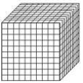
= 1,000
= 100
= 10
= 1

3,456 in base ten form would look like this.

Expanded form is when you use multiples of the place value to express your number and it looks like this:

3,456 = 3 ,000 + 400+ 50 + 6
Number Form is the form that we most often think of when we think of a number.
It’s the number written out in its numerical value.
Examples:
- 1
- 23
- 456
- 7891
Word Form is the number written out in words.
Examples:
- One
- Twenty- three
- Four hundred fifty-six
- Seven thousand eight hundred ninety-one

Let’s apply it!
= 1,000
= 100
= 10
= 1
How many
does it take to make one

10! Because 1,000 ÷ 100 = 10

Expanded form is when you use multiples of the place value to express your number.
Examples:
12 = 10 + 2
123 = 100 + 20 + 3
1,234 = 1,000 + 200 + 30 + 4
Think! How would you write the number 98,765 in expanded form?
90,000 + 8,000 + 700 + 60 + 5

Problem 3:
Write the number given in three forms:
10! Because 1,000 ÷ 100= = 10
Number Form
Word Form
Expanded Form
Base Ten Form
5,431
Five thousand, four hundred thirty-one
5,000 + 400 + 30 + 1

Place the digits in their place value in the house below.
Where should the comma placed?

654239
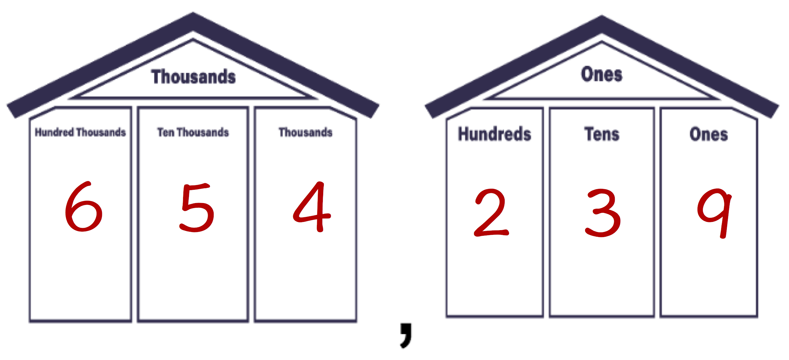
,
Problem 4:
Write the number given in the three forms
Number Form
Word Form
Expanded Form
Base Ten Form
3,215
Three thousand, two hundred fifteen
3,000 + 200 + 10 + 5

