Review
- Start naming new place value units by how many one thousands, ten thousands, and hundred thousands there are.
- Commas are used to show the grouping of units.
Problem 1:
350654
How many thousands are in the number?
There are ___________ thousands.
How many hundreds are in the number?
There are ___________ hundreds.
How many hundred thousands are there?
There are ____________ hundred thousands.
Where should the comma be placed?
Problem 2:
7235642
How many thousands are in the number?
There are ________thousands.
How many hundreds are in the number?
There are ________ hundreds.
How many hundred thousands are there?
There are ______ hundred thousands.
Where should the comma(s) be placed?

Number form is how we write numbers with digits.
3,456 is in number form.

Word form uses words like “hundred” and “thousands” to say the number.
3,456 is said three thousand, four hundred fifty-six

Base Ten form uses base ten blocks to create numbers with base ten blocks.
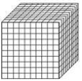
= 1,000
= 100
= 10
= 1

3,456 in base ten form would look like this.

Expanded form is when you use multiples of the place value to express your number and it looks like this:

3,456 = 3,000 + 4000+ 50 + 6
Number Form is the form that we most think of when we think of a number.
It’s the number written out in its numerical value.
Examples:
- 1
- 23
- 456
- 7891
Word Form is the number written out in numerical words.
Examples:
- One
- Twenty- three
- Four hundred fifty-six
- Seven thousand eight hundred ninety-one

Let’s apply it!
= 1,000
= 100
= 10
= 1
How many
does it take to make one

Write a sentence.

___________________________________________________.

Expanded form is when you use multiples of the place value to express your number.
Examples:
12 = 10 + 2
123 = 100 + 20 + 3
1,234 = 1,000 + 200 + 30 + 4
Think! How would you write the number 98,765 in expanded form?

____________________________________________________

Problem 3:
Write the number given in three forms:
10! Because 1,000 ÷ 100= = 10
Number Form
Word Form
Expanded Form
Base Ten Form
5,431
____________________________________
____________________________________________

How many of each?

_______

_______

Place the digits in their place value in the house below.
Where should the comma placed?

654239
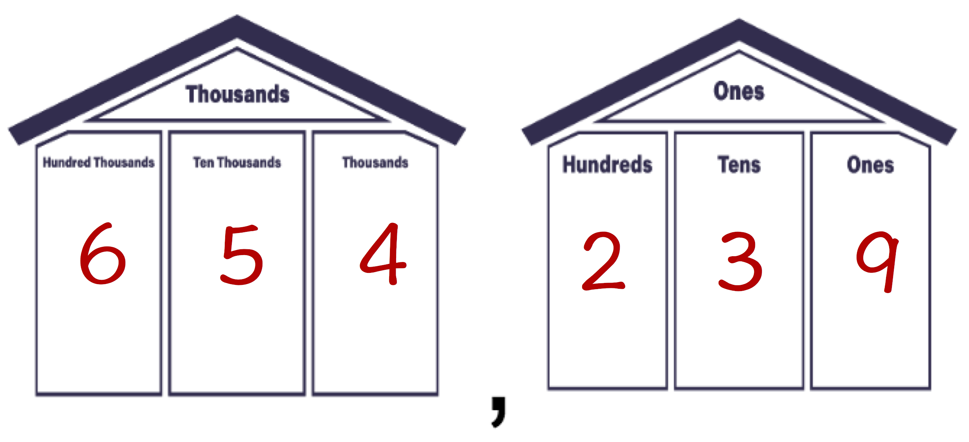
Problem 4:
Write the number given in the three forms
Number Form
Word Form
Expanded Form
Base Ten Form
3,215
________________________________________________________

How many of each?

________________________________________________________

_______

_______

