Math 4

1-1 Place Value of Whole Numbers
Name: |  | Date:

Common Core Standards | CCSS.MATH.CONTENT.4.NBT.1  Recognize that in a multi-digit whole number, a digit in one place represents ten times what it represents in the place to its right. For example, recognize that 700 ÷ 70 = 10 by applying concepts of place value and division.

1-1 Place Value of Whole Numbers
Place Value

Identify:
What is the place value of the 2?

642,517

Answer: The 2 is in the thousands place.

Place Value of Whole Numbers

Situation:
Kayla has 99 dollars and her grandmother gives her 1 more dollar for her birthday.
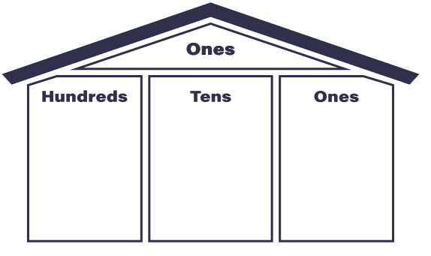

Write how many dollars she has total:
_, ___, ___
$
Tens
Ten Thousands
Hundred thousands
Thousands
Hundreds
Millions
Ones
When she writes out her new total to what place value will her number go?
__________________________
Part A: How many tens do you need to make a thousand?

10 tens = 1 hundred
10 hundred = 1 thousand
1 thousand = 10 hundred = how many tens?

1000 ÷ 10 = ___________

Part B: Look at the zeros to find the answer.
Example 1) 50 x 20 = 1,000 because 5 x 2 = 10 and then you add the two zeros that you were left with.
Example 2) 300 ÷ 50 = 60 because 30 ÷ 5 = 6 and you’re left with one extra zero to add onto the answer.
- How many is 10 one hundreds? | 100 x 100
- How many is 30 one thousands? | 30 x 1,000
- How many 100s are in a hundred thousand? | 100,000 ÷ 100

Part C: Task Cards
Match the pink card to the blue card with the correct matching phrase of the given numerical expressions.
1.  $$308$$ |  | a.  3,000
2.  $$900÷30$$ |  | b.  400

3.
$$10 x 900$$
c.
16,000

4.  $$800 x 20$$ |  | d.  186 hundreds
5.  $$18,600$$ |  | e.  9,000

6.
$$1,200 ÷30$$
f.
308 ones

 | ANSWER KEY
 | Situation 1 | $ 100 -  One hundreds place
 | Part A: | 100
 | Part B:
 | 1. | 10,000
 | 2. | 30,000
 | 3. | 1,000
Part C:
Task Cards
 | 1. |  | f.
 | 2. |  | a.
 | 3. |  | e.
 | 4. |  | c.
 | 5. |  | d.
 | 6. |  | b.

