What is place value?

Place value is the value of a digit depending on its location in a number. Each place value has a number from 1 to 9. We count up to 9 in each place and when we get to 10 we move into the next place value.

That means that the place value to the left of the digit is 10 x larger than the digit to its right. And that means the place value to the right of the digit is 10 x smaller than the digit to its left.

We start with ones and count up to 9, then we move on to tens. That means there are 10 ones in 1 ten. And that 1 ten is 10 times bigger than 1.

For example, there are 10 tens in 1 hundred so that means that
100 is ten times bigger than 10 ( 10 x 10 = 100 )

That also means that
10 is 10 times smaller than 100 ( 100 ÷ 10 = 10 )

10 Ones = 1 x 10 = 1 Ten
10 Tens = 10 x 10 = 1 Hundred
10 Hundreds = 10 x 100 = 1 Thousand
10 Thousands = 10 x 1,000 = 1 Ten Thousand
10 Ten Thousands = 10 x 10,000 = 1 Hundred Thousand
10 Hundred Thousands = 10 x 10,000 = 1 Million
1, 234, 567
Ten Thousands
Hundred thousands
Thousands
Hundreds
Millions
Ones
Tens

Notice that the digit 2 has a different value in the number 234,567 and 43,291.

In 2,468, the 2 represents 2,000. In 43,291, the 2 represents 200.

Put the number 325,698 in the houses.
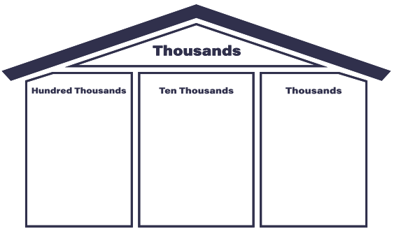,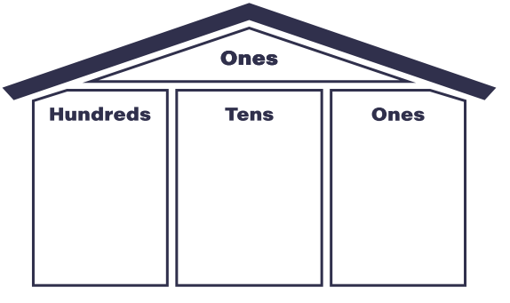

Time to Think

- Would you rather have 5 ones or 5 hundreds? Why?

- How many tens are in one thousand?

Draw a one dollar bill in the place value chart.
,
Now draw nine more one dollar bills in the place value chart.

What larger unit can I make?

When we exchange the ten ones for a ______, the _____ becomes _____ times as large.

Draw a ten dollar bill in the place value chart.
,
Now draw nine more ten dollar bills in the place value chart.

What larger unit can I make?

When we exchange the ten ten dollar bills for a ______, the _____ becomes _____ times as large.

465,312

Shade in the place value shapes and complete the table below to represent the number.

Hundred thousands | Ten thousands | Thousands | Hundreds | Tens | Ones
100,000 100,000  100,000 100,000  100,000 100,000 | 10,000 10,000  10,000 10,000  10,000 10,000 | 1,000 1,000  1,000 1,000  1,000 1,000 | 100 100  100 100  100 100 | 10 10  10 10  10 10 | 1 1  - 1  1 1

Time to think:
Using the base ten blocks below, circle four groups of 2 ten blocks. The first one is done for you. Then complete the multiplication statement.

4 x 20 = _____

Time to think
What do you notice about the multiplication statement and the answer? Write a sentence.

Using the hundred blocks below, circle three groups of 2 hundreds blocks. Then complete the multiplication statement.

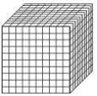

3 x 200 = _______

Time to think
What do you notice about the multiplication statement and the answer? Write a sentence.

Time to Think
Using what we learned about place value and using zeros as a tool:

- What is 800 ÷ 4?

- What about 1000 ÷ 10?

