Part A:
What is your favorite number? Write a sentence about why it is your favorite number.
Then draw your number as your favorite animal.

My favorite number is  3 because I have 3 dogs at home. Their names are Lucy, Ginny, and Max. | Drawing
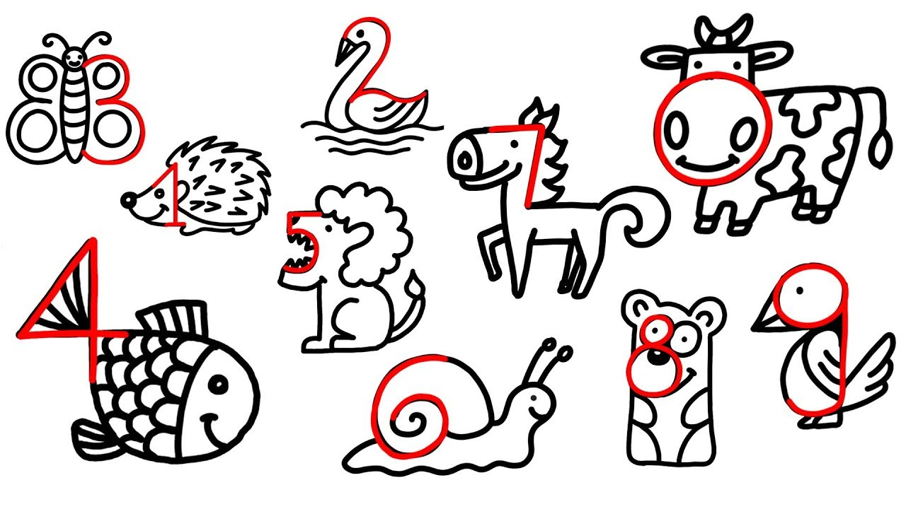

Part B:
Unscramble the words below and use it in a sentence.

- dduhrne
hundred
There are one hundred pencils in our classroom.
- eon
one
My little brother is one year old.
- dtaonhus
thousand
I want one thousand dollars for my birthday party.

Part C:
Who am I?
Look at the clues and use your mind to figure out the mystery numbers.

      - I am between 17 and 47.
I am divisible by 6.
I am 5 more than the number of days in December.
Who am I? 36
      - I am between 0 and 30
I am how many minutes have passed when you see the minute hand touching the number 2 on a clock.
I am 20 less than the number of days in November.
Who am I? 10
      - I am between fourteen and thirty-five.
I am a dozen plus 3.
I am divisible by 5.
Who am I? 15

