Part A:
Place Value Flower Puzzle
5 x 2 = how many tens?
2x100 = how many hundreds?
4,000 ÷ 2 = how many thousands?
10 x 1,000 = how many ten-thousands?
50 x 20,000= how many hundred thousands?

Find the answer to the problems in the puzzle and color in the answer below in the appropriate color.
- Color the tens yellow.
- Color the hundreds red.
- Color the thousands green.
- Color the ten thousands orange.
- Color the hundred thousands purple.
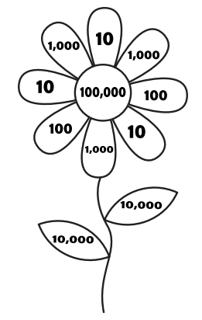

Part B:
Think about the value of 4 in the number 32,468. Write a new number where the number 4 is worth 10 times as much

______ x10 = ____________

Think about the value of 7 in the number 1,267,982. Write a new number where the number 7 is worth 10 times as much

______ x10 = ____________

Think about the value of 2 in the number 617,329. Write a new number where the number 2 is worth 10 times as much

______ x10 = ____________

Think about the value of 3 in the number 459,236. Write a number sentence to show the value of the 3 by multiplying by 10.

______ x10 = ____________

Think about the value of 4 in the number 617,432. Write a number sentence to show the value of the 4 by multiplying by 10.

______ x10 = ____________

Think about the value of 5 in the number 365,147. Write a number sentence to show the value of the 5 by multiplying by 10.

______ x10 = ____________

Write a x 100 statement to represent the value to 9 in 349,865...

______ x100 = ____________

Write a x100 statement to represent the value to 1 in 127,869…

______ x100 = ____________

Write a x 100 statement to represent the value to 8 in 687,452...

______ x100 = ____________

Write a ÷ 10 statement to represent the value of 7 in 687,452...

______ ÷10 = ____________

Write a ÷ 10 statement to represent the value of 4 in 349,865...

______ ÷10 = ____________

Write a ÷ 10 statement to represent the value of 2 in 127,869...

______ ÷10 = ____________

Part C:

Draw a model for each multiplication statement. Then give the answer.

3 x 200 = 4 x 30 =

5 x 20 = 2 x 400 =

Part D:

Multiply. You may draw a model.
6 x 30 = |  |  | 3 x 500 =
4 x 70 = |  |  | 6 x 800 =

