You are going to compare prices by finding the unit rate. Complete the tables below, show your division, and find the best cost per ounce.
- Record the price of the item…
- Find the size of the package in ounces…
- Write the ratio of price to ounces as a fraction…
- Find the unit rate by dividing the cost by the number of ounces in the package…
- Round to the nearest cent and record the cost per ounce…
- Explain which is the better buy and why…

Snack Food  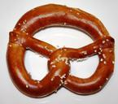 | Price of Item  Be sure to label with $ | Size of Package in ounces  Be sure to label with oz. | Ratio in the form of a Fraction  $$\frac{price}{ounce}$$ | Divide the price by the number of ounces to find the unit rate. | Unit Rate  Be sure to Label $/oz.
Large Box Pretzels
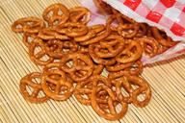
Pretzels - Small
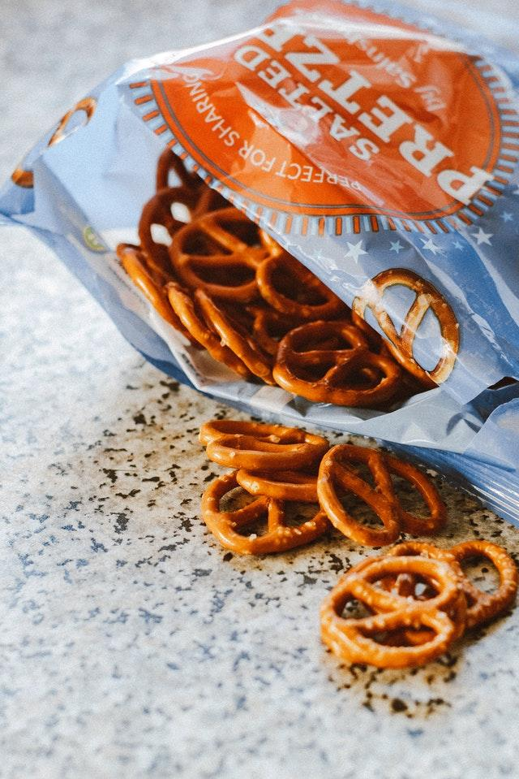
Which is the better buy and why?

Snack Food  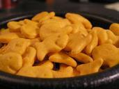 | Price of Item  Be sure to label with $ | Size of Package in ounces  Be sure to label with oz. | Ratio in the form of a Fraction  $$\frac{price}{ounce}$$ | Divide the price by the number of ounces to find the unit rate. | Unit Rate  Be sure to Label $/oz.
Goldfish Crackers
Family Size

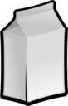
Goldfish Crackers
Standard Size Bag
Which is the better buy and why?

Snack Food  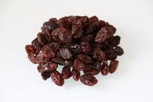 | Price of Item  Be sure to label with $ | Size of Package in ounces  Be sure to label with oz. | Ratio in the form of a Fraction  $$\frac{price}{ounce}$$ | Divide the price by the number of ounces to find the unit rate. | Unit Rate  Be sure to Label $/oz.
Raisins
Large Container
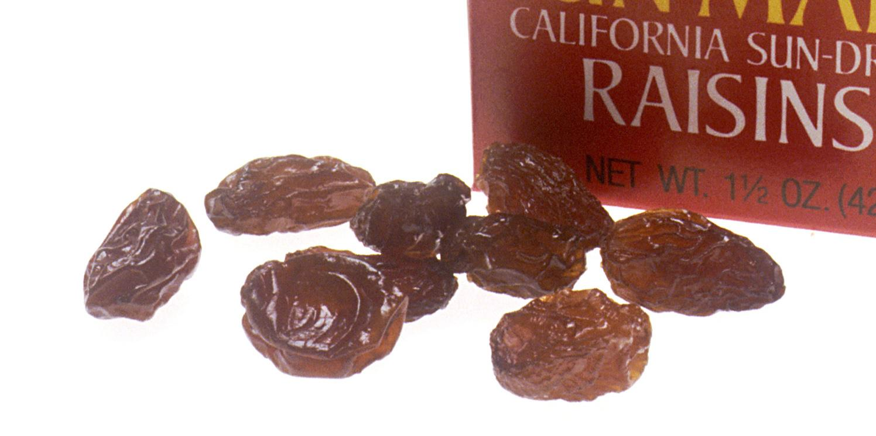
Raisins
Snack Size Boxes

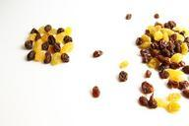
Which is the better buy and why?

BLANK TABLE
This table can be used if different snacks are used.
Snack Food | Price of Item  Be sure to label with $ | Size of Package in ounces  Be sure to label with oz. | Ratio in the form of a Fraction  $$\frac{price}{ounce}$$ | Divide the price by the number of ounces to find the unit rate. | Unit Rate  Be sure to Label $/oz.
Which is the better buy and why?

