Percent and Rates per 100
Percent is defined in many ways, below are some of them:
- It is a number expressed as a fraction of 100
- It means parts per 100
- It is a ratio that tells us “out of 100.
- It is a ratio where the second is 100.
The figure tells us that:
- there are “12 parts per 100”
- a ratio of 12 out of 100
- a ratio expressed as 12:100
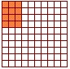

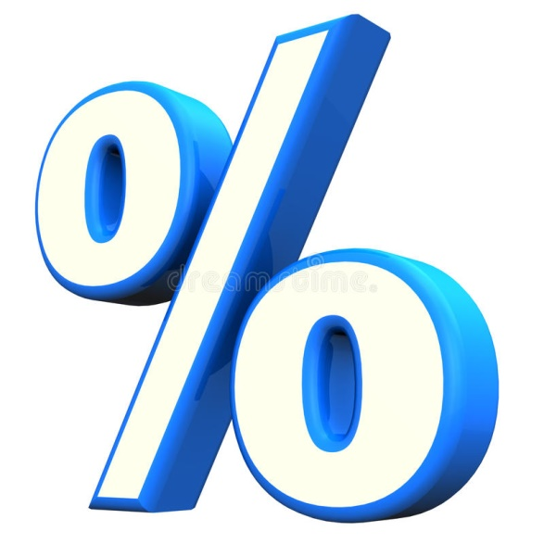
The percent symbol “%” is used as an easy way to write a fraction with a common denominator of 100.

So instead of writing “12 out 100”, we can write it as 12%.

Percent is a Rate per 100!

Percent can be expressed in many ways…
As a fraction: $\frac{12}{100}$
As a ratio: 12:100
As a decimal: 0.12
Using the percent symbol: 12%

Sample Problem 1:
Express the following quantities as percent.
a. 18 out of 100 b. 35 out of 100
Solution: 18% Solution: 35%

Writing Percent as Fractions Over 100
Expressing percent as a fraction is very easy! Remember that percent means “part of the whole”.
So 30% expressed as a fraction over 100 is $\frac{30}{100}$ .

Sample Problem 2:
Write the following as fractions over 100.
a. 25% b. 67%
Solution: $\frac{25}{100}$ Solution: $\frac{67}{100}$

Writing Percent to a Decimal (to the hundredths place)
There are a number of ways to express percent to decimals.

- Dividing by 100
Step 1: Express the given percent as a fraction of 100
Step 2: Divide the resulting fraction.

Example: Express 46% in decimal.
Step 1: $\frac{46}{100}$
Step 2: 0.46
46% = 0.46

- Move the Decimal
One of the easiest ways to convert a percent to a decimal is by simply moving it two places to the left!

Example: Express 35% in decimal.
35% = 0 . 3 5

- Multiplying the Given Percent by 0.01
Example: Express 24% in decimal.
24% x 0.01 = 0.24

Sample Problem 3:
Express the given percent into decimal (to the nearest hundredths).
- 33% b. 51% c. 75. 6873%
Solution: 0.33 Solution: 0.51 Solution: 0.76

Finding the Percent of a Given Number
To find the percent of a given number follow the steps below:
Step 1: Change the given percent to decimal.
Step 2: Multiply the quantities.

Example: What is 20% of 70?
Step 1: 20% = 0.20
Step 2: (0.20)(70) = 14
20% of 70 is 14

Sample Problem 4:
What is 15% of 20
Solution: (0.15)(20) = 3

