Equivalent Ratios

Remember that a ratio is a comparison of two quantities and each ratio can be written in another way.
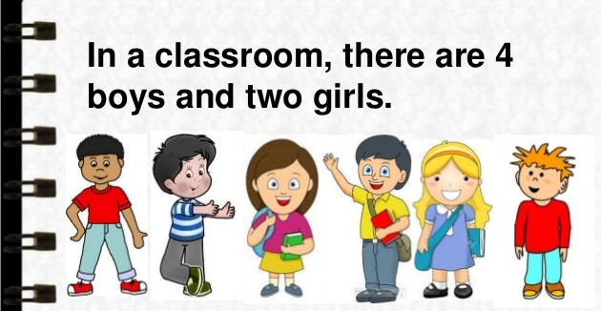

For instance, the illustration above shows a comparison between the number of boys to the number of girls, expressed as 4:2.

But 4:2 can also be written as 2:1.

4:2 and 2:1 are EQUIVALENT RATIOS

How do we write equivalent ratios?
Equivalent ratios can be determined by SCALING UP or SCALING DOWN a ratio.

SCALING UP A RATIO
We scale up a ratio by a scale factor, which means multiplying each term of the ratio by a given scale factor.

Example: Give 3 equivalent ratios for 2:3.

2 x 4 : 3 x 4
8 : 12
2:3 is scaled up to 8:12 by a scale factor of 4
2:3 = 8:12

2 x 3 : 3 x 3
6 : 9
2:3 is scaled up to 6:9 by a scale factor of 3
2:3 = 6:9

2 x 2 : 3 x 2
4 : 6
2:3 is scaled up to 4:6 by a scale factor of 2
2:3 = 4:6

2:3, 4:6, 6:9 and 8:12 are ALL equivalent ratios!

Sample Problem 1:
Which among the following is an equivalent ratio of 3:5? Give all possible answers.
- 6:15 b. 9:10 c. 6:10 d. 12:20 e. 45:75

SCALING DOWN A RATIO
We scale down a ratio by a scale factor, which means dividing each term of the ratio by a given scale factor.

Example: Give 3 equivalent ratios for 24:48.

24$÷$24 : 48$÷$24
1 : 2
24:48 is scaled down to 1:2 by a scale factor of 24
24:48 = 1:2

24$÷$12 : 48$÷$12
2 : 4
24:48 is scaled down to 2:4 by a scale factor of 12
24:48 = 2:4

24$÷$2 : 48$÷$2
12 : 24
2:3 is scale down to 12:24 by a scale factor of 2
24:48 = 12:24

24:48, 12:24, 2:4 and 1:2 are ALL equivalent ratios!

Sample Problem 2:
Which among the following is an equivalent ratio of 36:18? Give all possible answers.
a. 1:2 b. 4:2 c. 2:1 d. 12:6 e. 6:12

But there is another way!!!
To determine equivalent ratios, you need to follow these steps.
Step 1: Express the ratios in fraction form.
Step 2: Express the fractions in lowest term.
Step 3: If the fractions in lowest term are equal, then the ratios are
equivalent.

Example: Are 2:3, 4:6, 6:9 and 8:12 equivalent fractions?
Step 1: $\frac{2}{3}$, $\frac{4}{6}$, $\frac{6}{9}$ and $\frac{8}{12}$
Step 2: $\frac{2}{3}$,$\frac{2}{3}$, $\frac{2}{3}$ and $\frac{2}{3}$
Step 3: Therefore, 2:3, 4:6, 6:9 and 8:12 are equivalent ratios.

Sample Problem 3:
Show that the following ratios 6:10, 12:20 and 15:25 are equivalent ratios.

Finding the Unknown Term in Equivalent Ratios
Example: Find the unknown term in the equivalent ratios 12:16 and 6:x
Method 1:
Step 1: Express the equivalent ratios as fractions.
$$\frac{12}{16}= \frac{6}{x}$$
Step 2: Cross multiply
12x = 96
Step 3: Solve for the unknown
$\frac{12x}{12}= \frac{96}{12}$
X = 8

Method 2:
Step 1: Equate the equivalent ratios
12:16 = 6:x
Step 2: Multiply the inner terms and the outer terms.
12 : 16 = 6 : x

Here, 16 and 6 are the inner terms and 12 and x are the outer terms.
(12)(x) = (16)(6)
12x = 96
$$\frac{12x}{12}= \frac{96}{12}$$
X = 8

Sample Problem 4:
The ratio of boys to girls in a photography club is 3:4, If there are 12 boys, how many girls are there?

Table of Equivalent Ratios
Equivalent ratio tables are tables that show the relationship of two values. Each and every ratio in the table is exactly the same as the all the others. The values in an equivalent ratio has either been scaled up or scaled down.

Meters | Centimeters
1 | 100 | 1:100
2 | 200 | 1:100
3 | 300 | 1:100
4 | 400 | 1:100
5 | 500 | 1:100
6 | 600 | 1:100

The table of equivalent ratios is used to solve problems involving ratios with ease.

Sample Problem 5:
Mark can type 30 words per minute. Complete the table of equivalent ratios and answer the questions that follow.

Minutes | Number of Words

- How many words can Mark type in 5 minutes?

- How long can Mark type 210 words?

Finding the Missing Values in a Ratio Table
The process in finding the missing terms in a ratio table is the same as finding equivalent ratios.

Example: Find the missing values.
3 | 4  To solve for y  $\frac{12}{16}=\frac{y}{20}$  16y = 240  X = 15  To solve for x  $\frac{3}{4}=\frac{6}{x}$  3x = 24  X = 8
6 | x
12 | 16
y | 20
18 | 24

Ratios on Coordinate Plane
The pairs of values in the table of equivalent ratio can be plotted in a coordinate plane. The graph should be a straight line

Example:
Plot the table of equivalent ratios in a coordinate plane.

Step 1: Write the pairs of values in the table as coordinates.

Meter/s | Centimeters |  | x | y | (x,y)
1 | 100 |  | 1 | 100 | (1, 100)
2 | 200 |  | 2 | 200 | (2, 200)
3 | 300 |  | 3 | 300 | (3, 300)
4 | 400 |  | 4 | 400 | (4, 400)
5 | 500 |  | 5 | 500 | (5, 500)
6 | 600 |  | 6 | 600 | (6, 600)

Step 2: Plot the points and connect so you could scale up or scale down the values.
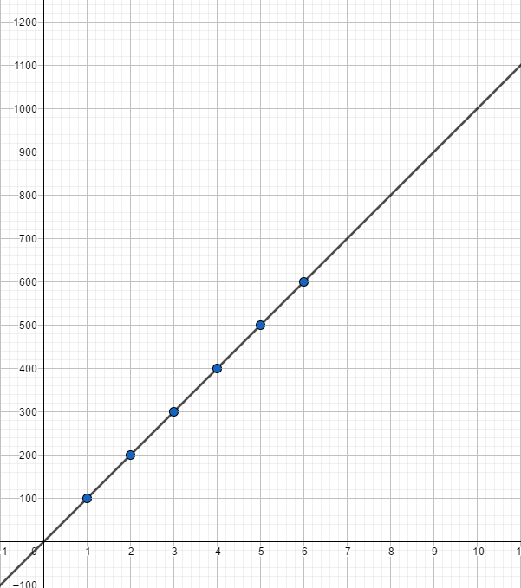

Sample Problem 6:
Make a table of equivalent ratios for 1:5 and plot the points in a coordinate plane.

1:5 |  |  | x | y | (x,y)

