Ratio vs. Rates
Ratio is any comparison of two numerical measurements. Each measurement is called a "term."

The ratio of bananas to apples is
2:5

Rate is a little bit different than the ratio, it is a special ratio. It is a comparison of measurements that have different units.

Example:
If 15 burgers cost $75, the rate is $75 for 15 yummy burgers. In ratio:
$75 : 15
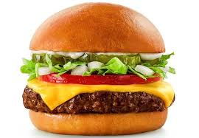

Here, the first term of the ratio is the price in dollars and the second term is the number of burgers. You can write this rate as $75/15 burgers or $75:15 burgers. Both expressions mean that you pay $75 "for every" 15 burgers.

Sample Problem 1:
Tell whether the given quantities represent a mere RATIO or a RATE.
- 10 pieces of red pens to 6 pieces of blue pens
Solution: RATIO
- 200 miles to 4 hours
Solution: RATE

Unit Rate is a rate in which the second term equals "1". If you want you determine a unit rate, you need to know how much of the first term exists for every one unit of the second term.

Example:
Here, the rate is $2.49 for every kilo of tomatoes, or in ratio $2.49:1.
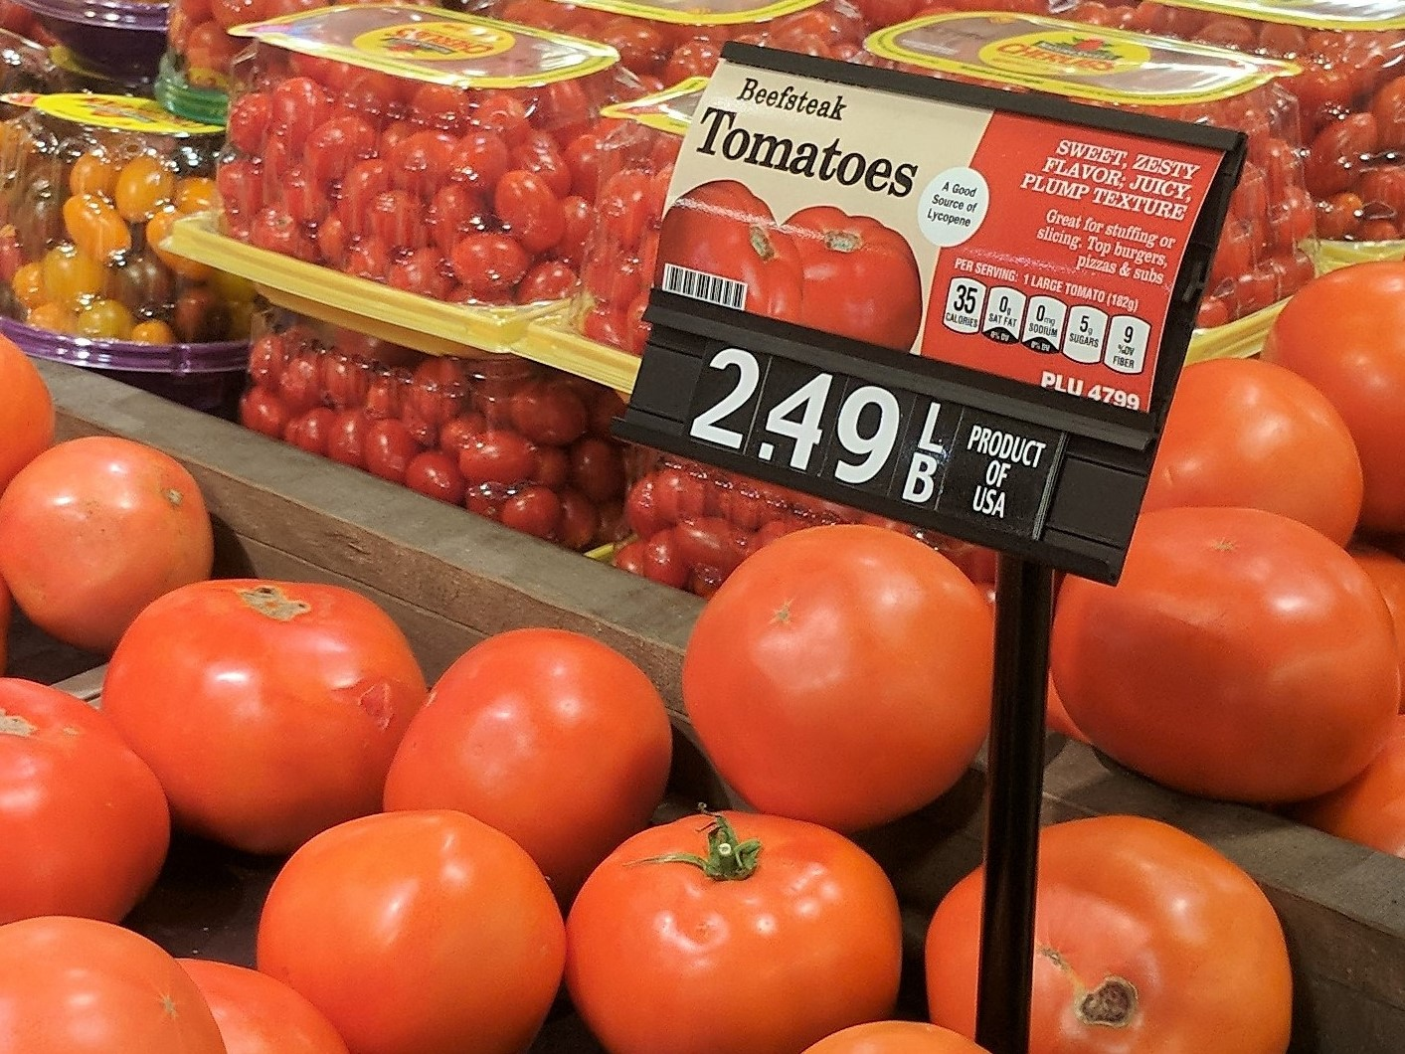

Notice that the value of the second term in the ratio is 1. Therefore, when rates are expressed as a quantity of 1, then the rate
$2.49 per kilo is a unit rate.

And since ratios can be expressed as fractions, it is also CORRECT to say that a unit rate has 1 as the denominator.

$2.49:1. or $\frac{\$2.49 }{1}$ or $2.49 per kilo

Sample Problem 2:
Which among the given quantities express a unit rate?
- 90 words per 30 minutes
- 3 words per minute
- 180 words per hour
- 60 words per 20 minutes

How Do We Calculate the Unit Rate?
Step 1: Check what information is given.
The problem must have two terms, and you must be asked to determine how much of one term exists per unit of the other term.

Some common examples are:
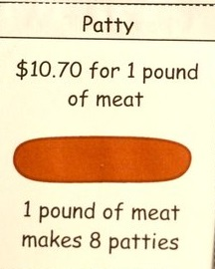
- miles/kilometers per hour
- dollars per kilo
- price per item
- salary per month

Example:
A bakeshop can bake 400 chocolate cupcakes in an 8 hour work day. How many chocolate cupcakes can that same bakeshop make in one hour? In other words, how many chocolate cupcakes are typically baked per hour?
CHOCOLATE CUPCAKES PER HOUR
First term Second term

Step 2: Rewrite the given date as a quotient or a fraction.
$\frac{First Term}{Second Term}$ $\frac{400 Chocolate Cupcakes}{8 hours}$

Step 3: Divide the first term (numerator) and the second term (denominator) by the value of the denominator.

Remember that we want to express the rate as a SINGLE unit which means that the denominator MUST be equal to 1.

$$\frac{400 Chocolate Cupcakes}{8 hours}$$

400 Chocolate cupcakes / 8 = 50
8 hours / 8 = 1

$$\frac{400 Chocolate Cupcakes}{8 hours}=\frac{50 Chocolate Cupcakes}{1 hour}$$

Step 4: Write the unit rate expression.

Therefore, the bakeshop can bake 50 chocolate cupcakes per hour.

Sample Problem 3:
Answer the problem.

James traveled 200 miles in 4 hours. If he used the same speed the entire trip, how fast did he drive miles per hour?

Solution:
Step 1: 200 miles in 4 hours
Step 2: $\frac{200 miles}{4 hours}$
Step 3: 200 miles / 4 = 50
4 hours / 4 = 1
Step 4: Therefore, he drives 4 miles per hour.

