Ratio

Ratio is a comparison between, or a relationship of two things.

Examples:
There is 1 ice cream cone to 3 cookies.

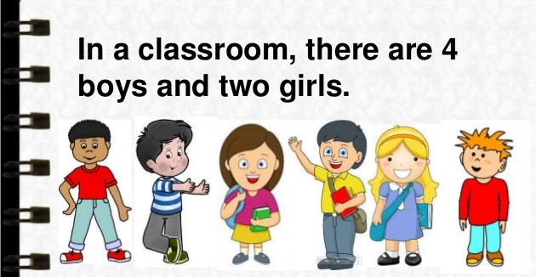

There are 4 boys to 2 girls.

Ratios can be shown in different ways!

There is 1 ice cream cone to 3 cookies.

- Use the “:” to separate the values (read as 3 is to 1). | 1:3
- We can also use the word “to” | 1 to 3
- We can write it as a fraction. | $$\frac{1}{3}$$

Sample Problem 1:
Write in three different ways the ratio of the given figure.
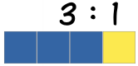

Solution:
The ratio of 3 blue rectangles to 1 yellow rectangle.
3 : 1
3 to 1
$\frac{3}{1}$

Sample Problem 2:
Answer the following questions given the picture below.

- What is the ratio of apples to bananas?
Solution: 5 : 2

- What is the ratio of bananas to apples?
Solution: 2 : 5

Equal Ratios

To find an equal ratio, you can either multiply or divide each term in the ratio by the same number (but not zero).
Here, the ratio is also 3 blue squares to 1 yellow square, even though there are more squares.

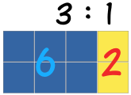

3 : 1
x 2 x 2

6 2

Or it could be the other way around…
6 : 2
/ 2 / 2

3 1

Therefore, 3 : 1 = 6 : 2

How do we know that the RATIOS are EQUAL?

Example: Are the ratios 4 : 1 and 12 : 3 equal?

Step 1: Find the quotient of the numbers in the ratio.
4 $÷$ 1 = 4 12 $÷$ 3 = 4

Step 2: If the quotients are the SAME, then ratios are EQUAL!
4 : 1 = 12 : 3

Sample Problem 3:
Are the ratios 3 : 4 and 12 : 16 EQUAL or NOT?

Solution:
3 $÷$ 4 = 0.75
12 $÷$ 16 = 0.75
Therefore, 3 : 4 = 12 : 16

Reducing Ratios
Reducing ratios is similar to reducing a fraction in lowest terms since ratios can be expressed as fractions.

Example:
Reduce 12:16 in lowest terms.

Step 1: Find the GCF of the numbers in the ratio.
GCF is 4

Step 2: Divide the numbers in the ratio by the GCF.
$\frac{12}{4} : \frac{16}{4}$ 3 : 4

IMPORTANT: Ratios are in lowest terms if and only if, the Greatest Common Factor left is 1.

Sample Problem 4:
Reduce 16 : 24 in lowest term.
Solution:
GCF is 8 $\frac{16}{8} : \frac{24}{8}$ 2 : 3

Sample Problem 5:
Who wants some yummy pancake?

A recipe for pancakes uses 3 cups of flour and 2 cups of milk. To make pancakes for a LOT of people we might need 4 times the quantity.

- What is the ratio of flour to milk in the original recipe?
Solution: 3 : 2

- What is the ratio of flour to milk in the NEW recipe?
Solution:
3 x 4 : 2 x 4 = 12 : 8
12 cups of flour to 8 cups of milk for a yummy pancake

