Ratio

Ratio is a comparison between, or a relationship of two things.

Examples:
There is 1 ice cream cone to 3 cookies.

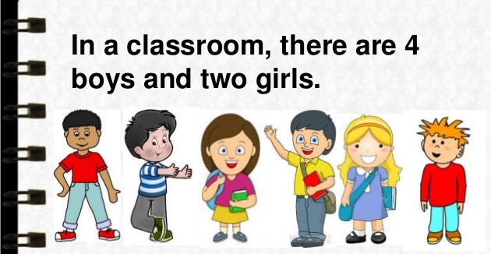

There are 4 boys to 2 girls.

Ratios can be shown in different ways!

There is 1 ice cream cone to 3 cookies.
.
- Use the “:” to separate the values (read as 3 is to 1). | 1:3
- We can also use the word “to” | 1 to 3
- We can write it as a fraction. | $$\frac{1}{3}$$

Sample Problem 1:
Write in three different ways the ratio of the given figure.
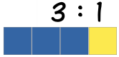

Sample Problem 2:
Answer the following questions given the picture below.

- What is the ratio of apples to bananas?

- What is the ratio of bananas to apples?

Equal Ratios

To find an equal ratio, you can either multiply or divide each term in the ratio by the same number (but not zero).

Here, the ratio is also 3 blue squares to 1 yellow square, even though there are more squares.

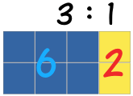

3 : 1
x 2 x 2

6 2

Or it could be the other way around…
6 : 2
/ 2 / 2

3 1

Therefore, 3 : 1 = 6 : 2

How do we know that the RATIOS are EQUAL?

Example: Are the ratios 4 : 1 and 12 : 3 equal?

Step 1: Find the quotient of the numbers in the ratio.
4 $÷$ 1 = 4 12 $÷$ 3 = 4

Step 2: If the quotients are the SAME, then ratios are EQUAL!
4 : 1 = 12 : 3

Sample Problem 3:
Are the ratios 3 : 4 and 12 : 16 EQUAL or NOT?

Reducing Ratios
Reducing ratios is similar to reducing a fraction in lowest terms since ratios can be expressed as fractions.

Example:
Reduce 12 : 16 in lowest terms.

Step 1: Find the GCF of the numbers in the ratio.
GCF is 4

Step 2: Divide the numbers in the ratio by the GCF.
$\frac{12}{4} : \frac{16}{4}$ 3 : 4

IMPORTANT: Ratios are in lowest terms if and only if, the Greatest Common Factor left is 1.

Sample Problem 4:
Reduce 16 : 24 in lowest term.

Sample Problem 5:
Who wants some yummy pancake?

A recipe for pancakes uses 3 cups of flour and 2 cups of milk. To make pancakes for a LOT of people we might need 4 times the quantity.

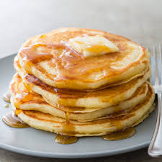

- What is the ratio of flour to milk in the original recipe?

- What is the ratio of flour to milk in the NEW recipe?

