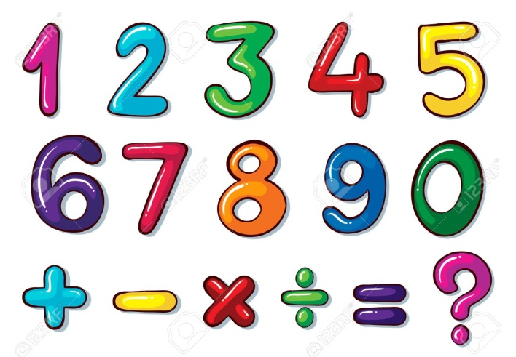
What are NUMERICAL EXPRESSIONS?
A numerical expression is a mathematical phrase that represents a single value. It consists of one or more numbers and operations.

These operations involve Addition, Subtraction, Multiplication and Division.

The picture shows the numbers and operations that you can mix up to form a numerical expression. Also, remember that there should be NO equal sign “=” in the expression, because that would be a different story !

Expressions WITH or WITHOUT Parentheses
This lesson is an in-depth discussion of when to use and, not to use parentheses in translating verbal expressions into numerical expressions.

When do you use parenthesis?
Parentheses, with the symbol “( )”, in numerical expressions is used to:

Separate numbers for accuracy and clarity
$$10+(-3)$$

Indicate multiplication
$$10(3)$$

$$10-(3+5)$$
Group numbers to order the given operations

How do you compare a verbal phrase with parentheses and without them?

Compare the statements below:
Example 2:
Eleven minus five plus four

Example 1:
Eleven minus the sum of five and four

Parentheses for numerical expressions are used to group numbers with operations that must be done first. Let’s compare the two verbal phrases above and let’s find out which one needs parentheses, and which one does not.

Example 1:
Eleven minus the sum of five and four
If you are asked to translate the verbal phrase above to its corresponding numerical expression, you need to READ and UNDERSTAND the phrase carefully.

Eleven minus the sum of five and four

Here, you really have to pay attention to the clues… PLUS and SUM both mean to ADD. But… the word “sum” in the phrase above, must be grouped, enclosed in PARENTHESES, and must be performed first.

So… going back to the example:
Eleven minus the sum of five and four

will be translated as a numerical expression:
$$11-(5+4)$$

Example 2:
Eleven minus five plus four
The same thing goes for this example; you need to READ and UNDERSTAND the phrase carefully.
Eleven minus five plus four
The standard way to translate this verbal phrase into a numerical expression is:
$$11-5+4$$

Notice that everything is still there, except the “parentheses”. Here instead of the word “sum”… the word “plus” is used. There is no need for grouping in this type of example.
Each expression when evaluated will give different values.

Sample Problem 1:
Highlight the verbal phrase that needs parentheses GREEN.
- The sum of three times four plus seven
- Three times four plus seven
- Three times the sum of four and seven
- Ten divided by two times five
- The quotient of ten and two times five
- Ten divided by the product of two and five

Solution:
Highlight the verbal phrase that needs parentheses GREEN.
- The sum of three times four plus seven
- Three times four plus seven
- Three times the sum of four and seven
- Ten divided by two times five
- The quotient of ten and two times five
- Ten divided by the product of two and five

Sample Problem 2:
Translate the statements in Sample Problem 2 into numerical expressions. Place the parentheses (if needed) correctly.
- The sum of three times four plus seven | $$\left(3×4\right)+7$$
- Three times four plus seven | $$3×4+7$$
- Three times the sum of four and seven | $$3×(4+7)$$
- Ten divided by two times five | $$10÷2×5$$
- The quotient of ten and two times five | $$(10÷2)×5$$
- Ten divided by the product of two and five | $$10÷(2×5)$$

