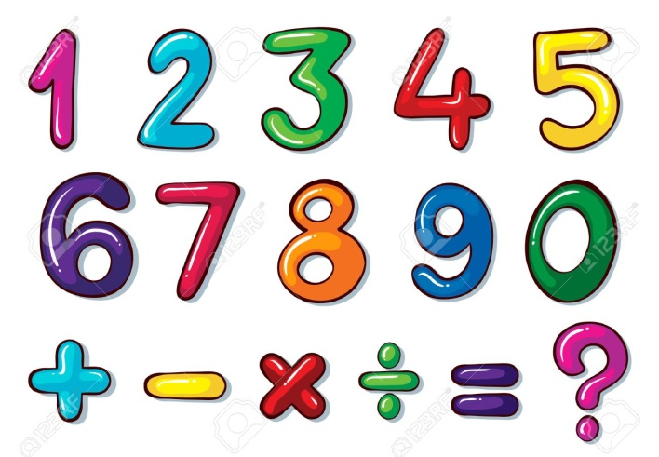**What are NUMERICAL EXPRESSIONS?**

A numerical expression is a mathematical phrase that represents a **single value**. It consists of one or more **numbers** and **operations**.

These operations involve **Addition**, **Subtraction**, **Multiplication** and **Division**.

The picture shows the numbers and operations that you can mix up to form a numerical expression. Also, remember that there should be **NO** equal sign “**=**” in the expression, because that would be a different story ☺!

**Sample Problem 1:**

Which among the following is a numerical expression?

$x+y+3$

$1+3=2+2$

$\left(4+5\right)÷3$

$24×(9-1)$

**Solution:**

The correct answers are C and D.

**Writing Numerical Expressions**

**How do I write numerical expressions?**

In writing numerical expressions from verbal statements, you need to familiarize yourself with the **CLUES**!!! These clues are words that are used to represent the four operations: addition, subtraction, multiplication and division. These words/phrases are identified below:

|  |  |  |  |
| --- | --- | --- | --- |
| **Addition** | **Subtraction** | **Multiplication** | **Division** |
| the sum of  plus  increased by  more (than)  and  total of  raised  combined  added to  together  add  additional  in all | the difference  less than  diminish  minus  decrease (by)  go down  subtract from  reduce  drop  fewer than  left  lost  taken from | multiplied  times  twice  tripled  doubled  product | divided (by)  average  ratio  quotient  per  part  shared equally  __ out of __  split |

**Example 1:**

Write a numerical expression given the verbal phrase below:

**The sum of nine and five multiplied by three**

Looking at the given example, you have to understand that you need to get the sum of nine and five first, and multiply whatever the answer is to three.

This should be done first **the sum of nine and five**

Then, whatever the answer is **multiply it by three**

**So how do we write it as a numerical expression?**

We need to do some sort of **grouping**, to indicate that one operation must be done first, before doing another. We use open/close parentheses “( )”,to group the numbers and operations.

The operation that must be done first must be enclosed in parentheses.

**(The sum of nine and five) multiplied by three**

**This must be enclosed in parentheses because the given phrase calls for the sum of 9 and 5 first.**

So the numerical expression we can get is:

**The sum of nine and five multiplied by three**

$$(9+5)×3$$

**Example 2:**

Write a numerical expression given the verbal phrase below:

**The sum of nine and the product of five and three**

If you compare it to the first example, both involve the same numbers and the same operations.

Example 1: **The sum of nine and five multiplied by three**

Example 2: **The sum of nine and the product of five and three**

Both examples involve numbers nine, five and three, and operations addition and subtraction. But do they really mean the same?

BIG NO!!!

In Example 2, “**The sum of nine and the product of five and three**”, the operation that must be done first is to multiply five and three… then add nine to whatever the product is. The grouping will then be:

**The sum of nine and (the product of five and three)**

$$9+(5×3)$$

**Let’s compare the two verbal phrases!**



Here, we can say that both verbal statements may have exactly the same numbers and may involve that same operations; they mean differently though. Pay close attention to the given phrase and group the numbers with operations that must be done first.

The examples above will also give **DIFFERENT** answers when evaluated.

**Sample Problem 2:**

Tell whether the given phrases below have the same meaning, or not, by writing their corresponding numerical expression.

1. The difference between twenty and twelve divided by two
2. The difference between twenty and the quotient of twelve and two

**Solution:**

1. The difference between twenty and twelve divided by two
$$(20-12)÷2$$

2. The difference between twenty and the quotient of twelve and two

$$20-(12÷2)$$

The given phrases do not mean the same.

**Now, let’s do it the other way around!!!**

**Translating Verbal Phrases into Numerical Expressions**

Instead of writing numeral expressions given the verbal phrases, you’ll do it the other way around. You are going to translate numerical expressions into words. Remember that the **ORDER OF OPERATIONS** is very **IMPORTANT**!!!

Always pay attention to **“What should be done first?”**

**How do I write numerical expressions into verbal phrases?**

**Example 3:** Translate $24÷(8-4)$ into words.

As mentioned, take note of the order of operations and **“What should be done first?”**

In this example, which verbal phrase do you think is correct?

1. Twenty four divided by eight minus four
2. Twenty four divided by the difference of eight and four

**The correct answer is B.**

Take note that there are numbers to be grouped in the given example, and should be done first.

$$24÷(8-4)$$

Twenty four divided by the difference of eight and four

**A** on the other hand is incorrect.

**“Twenty four divided by eight minus four”**

Looking at the order of operations, the numerical expression for this verbal phrase is $(24÷8)-4.$

**Sample Problem 3:**

Translate each numerical expression into words and write them in each cloud.

|  |  |  |
| --- | --- | --- |
| 1. | $$\left(4×5\right)+10$$ |  |
| 2. | $$4×(5+10)$$ |  |
| 3. | $$30÷\left(5+1\right)×\left(7-3\right)$$ |  |
| 4. | $$\left(30÷5\right)+\left(1×7\right)-3$$ |  |
|  |  |  |

Solution: (Answers may vary)

1. Four times five plus ten.
2. Four times the sum of five and ten
3. Thirty divided by the sum of five and one times the difference of seven and three
4. Thirty divided by five plus the product of one and seven, minus three

**Interpreting Numerical Expressions**

How are numerical expressions interpreted without evaluating them? “**Evaluate**” means getting the value of a given numerical expression with the use of any given operation, following a correct order. But how is it done without evaluating?

**Without evaluating, compare the value of:**

$(20+4)$**and $5×(20+4)$**

To compare the values of the given numerical expressions without evaluating, the use of a visual model such as a **TAPE DIAGRAM** is used.

Using a tape diagram, we can draw the model of $(20+4)$,

$$(20+4)$$

and the model of $5×(20+4)$.

$(20+4)$ $(20+4)$ $(20+4)$ $(20+4)$ $(20+4)$

Without evaluating and by only drawing a model of the given numerical expressions, we can say that:

$5×(20+4)$**is 5 times as large as $(20+4)$.**

**Sample Problem 4:**

Without evaluating, which do you think has a bigger value? Draw the model to compare.

The sum of 12 and 8 tripled or $\left(3×12\right)+(3×8)$

**Solution:**

The sum of 12 and 8 tripled

8

12

8

12

8

12

v

$$\left(3×12\right)+(3×8)$$

8

8

8

12

12

12

v

Without calculating, the visual models clearly show that the sum of 12 and 8 tripled and $\left(3×12\right)+(3×8)$ have exactly the same value.

**Sample Problem 5:**

Compare the given numerical expressions using >, < or =, without calculating. Draw tape diagrams to help you decide.

$24×(20+5)$ $(20+5)×12$

**Solution:**

|  |  |
| --- | --- |
| $$24×(20+5)$$ | $$(20+5)×12$$ |
| one represents $(20+5)$ | one represents $(20+5)$ |

Therefore,

>

$24×(20+5)$ $(20+5)×12$

**Sample Problem 6:**

A pastry box contains 12 pcs of assorted cookies. Paul bought 3 boxes to be given to his parents and 5 boxes for his friends. Draw a tape diagram and write the numerical expression that shows the total number of cookies bought.

Solution:

Tape diagram:

12

12

12

12

12

+

12

12

12

The 5 boxes, with 12 cookies each, are for his parents.

The 3 boxes, with 12 cookies each, are for his parents.

Numerical Expression:

$$\left(3×12\right)+(5×12)$$